

**Internship Report**

By: Adel Sabri Al-Khaldi

Student ID: 202111238

Internship Start Date: 21/05/2024

Internship End Date: 21/9/2024

Working Hours: 640 Hours

Company Name: Al-Ain University ITC

## **Executive Summary**

The internship was at Al-Ain University’s IT Center in Al-Ain Branch, under the supervision of Muhammad Zuhoor, a DevOps Developer in ITC in Al-Ain University.

The internship dealt with a variety of technical topics covering web development, virtual environments in VirtualBox, oracle databases, oracle’s APEX setup, and basics of CRUD operations in APEX. Another important facet of this internship was getting to know the workplace environment and method of operation and interaction with colleagues and coordination skills.

Although the internship didn’t tackle very advanced topics, the main goal and purpose of these tasks is to be resilient and learn how to tackle problems and think critically and navigate through these issues to build a solid foundation to be able to navigate the current job market.

One of the biggest challenges faced are troubleshooting problems, especially in the Oracle project. Having a massive setup, middle-wear setup and navigation, using a variety of tools that interact with each other, Meant that I had to learn how to correctly configure and learn the infrastructure of the Oracle site. Referring to Oracle documentation continuously and reading up from a variety of online forums and going around dead ends to reach any solution.

Another aspect dealt with is IT support and helping students with registration and any potential issues they encounter. Managing students and referring them to the appropriate destinations individuals for their issues and explaining to them how the university systems operate and how to operate the websites and services properly

I’ve learnt how to deal with professional workspaces and environments and practiced professional etiquette and manners for future employment opportunities. I’ve also learned co-operation with my other interns and colleagues and supervisors to know how to ask for advice regarding issues I would encounter according to their skills to get the best advice possible.

Table of Contents

**Executive Summary** 2

**Table of Contents** 4

**Company Description** 6

**Web Development** 7

Front-End Responsive Websites: 7

Backend Development & XAMPP 12

**Oracle Project Overview** 17

University Library Requirements As a DBA 19

Creating a Database Schema 20

Oracle’s Data Modeler 24

**Oracle Database Overview** 25

Oracle Database Advantages 27

Virtual Machine Setup 28

Database Installation & Configuration 28

Database Installation Process 30

Creating a new PDB 31

Configuration of Networking Files 36

Navigation to & from PDBs and Setting to Boot-Up on Default 40

Creating SQL connection in SQL Developer 43

Implement ERD using SQL Developer 44

Inserting Data into Tables 46

**Overview Of Oracle APEX** 47

What is the Architecture Used? 48

What is the RAD stack ? 48

Oracle RAD Stack in Action: 48

Installation of Oracle Apex on LibraryDB PDB 49

**Backend Setup for Oracle APEX** 55

ORDS & Tomcat, Summary & Interaction 55

Apache Tomcat Setup 56

Workspaces in APEX 58

**Simple CRUD Operations Using APEX** 61

Creating an Application in APEX 61

Creating a Report with Form Page In APEX 62

Creating a View for Data in APEX’s SQL Workshop 68

**IT Support for Student Registration** 72

**Internship Assessment & How It Prepared Me** 74

**Technical Skills & Experience** 74

**Difference Between Theory & Practice** 75

**Soft Skills & Teamwork Skills** 76

**Conclusion** 77

**References** 78

# **Company Description**

**Company name:** Al Ain University ITC

Al-Ain University’s ITC provides Al-Ain University with IT services and technical support for its students and staff while protecting the university’s digital infrastructure from cyberthreats and providing all the technical skills and help for the other departments in the university.

**Address:**

Information Technology Center  
Al Ain University

P.O.Box: 64141  
Al Ain – UAE

**Contact details:**

Phone No: +971 3 7024888  
Fax No: +971 3 7024777  
E-mail: [ITC@aau.ac.ae](mailto:ITC@aau.ac.ae)

## **Web Development**

Internship began with revision on web development basics such as HTML, CSS, Javascript, PHP and SQL. They requested from us to make simple projects to do to exercise and create a background in web development. First, we began with online hosting of front-end websites being created before attempting to host them fully with backend.

### Front-End Responsive Websites:

The initial websites were hosted on codepen.io, An online code editor used by developers for frontend projects as it hosts HTML, CSS and Javascript files only. It has “pens” and “projects”, where pens can hold a single file of the mentioned supported files and projects can hold multiple. Since most projects didn’t require anything more than a single file, they were all hosted as pens.

First project created was using HTML & CSS exclusively, attempting to make it mobile friendly:

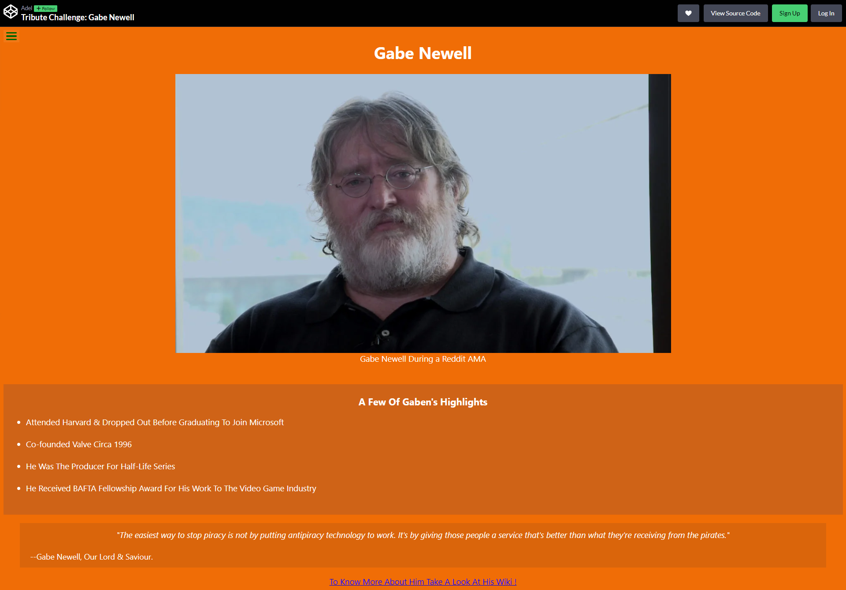

Figure 1, Simple Tribute Webpage as Desktop

The project was simple to create and has very minimal and basic design but the purpose was to test out the media query function in css to resize images and text to be accessible on mobile devices.

Media queries are a CSS feature that applies certain CSS Stylings depending on the device’s viewport width, for example this snippet of code in the figure 2.

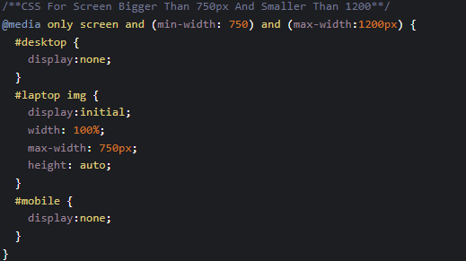

Figure 2, Showing how media queries operate

After successfully implementing the media query function in CSS, We were tasked with implementing two designs that are creative and original for a one page portfolio whether personal or for a company. The following requirements were required:

* Using External Libraries for Icons
* Using @import for CSS
* Fully Functional Front-End Websites
* Responsive Websites for Mobile Devices and Desktop using Media Queries

First one was a portfolio website for a company, using professional styling using white and dark grey styling using pure CSS and HTML.

Having the website be responsive was an issue with image rescaling as it can break the image and make it display in-correctly, so to circumvent that issue, the wavy background-image and the home page image was converted to SVG to display properly as SVGs can scale properly without losing resolution or need to fine tune it for every media query for every device.

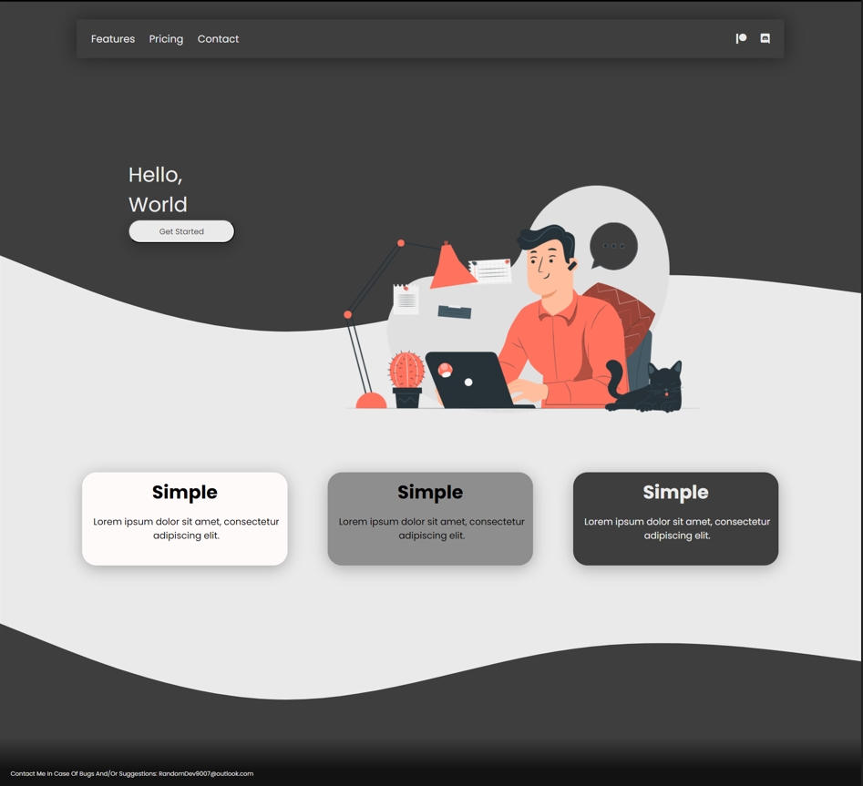

Figure 3, Showing First Portfolio Made

Second is a bit more colorful with a red and dark theme. Previously, only SVG images were embedded, this time I attempted to code with css for the lines that transition from one section to another.

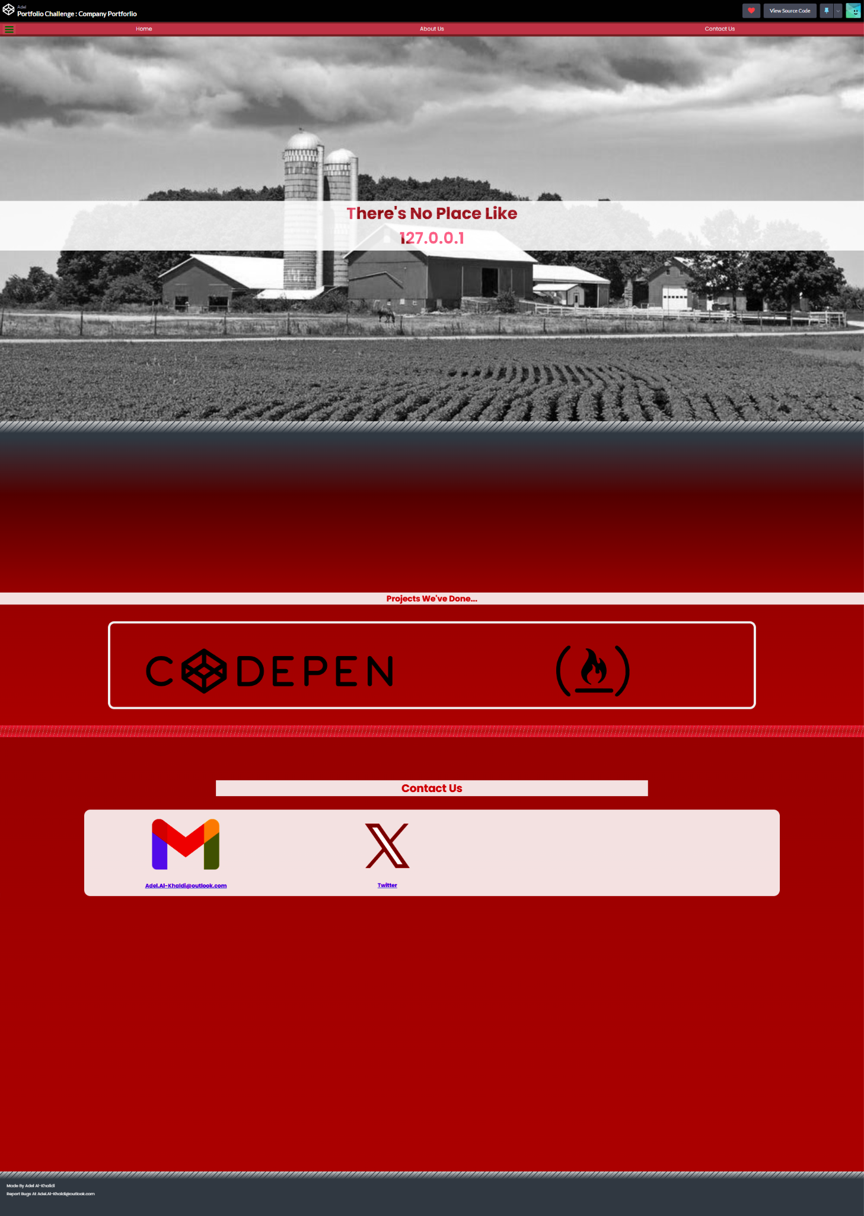

Figure 4, showing the second portfolio created

Last thing is a Javascript Calculator with addition, multiplication, subtraction and division. With basic functions such as clear and delete a number. All of this is meant to tutor some basics of coding in Javascript and dealing with variables and translating them back into HTML for display to the end user.

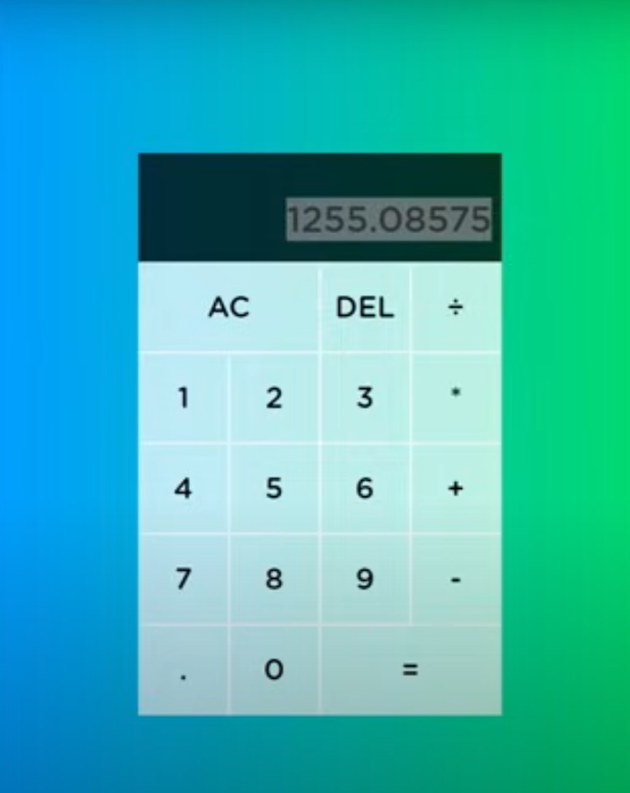

Figure 5, Showcasing a simple calculator using JavaScript

The next step to familiarize us with web development is using PHP and JavaScript for backend development using XAMPP

### Backend Development & XAMPP

XAMPP is an open-source & free software development tool made by Apache. It packages many functionalities to simplify and streamline the development process to setup a local web development environment that also deals with backend in a complete package. XAMPP has many packaged modules but the ones that will be utilized are:

1. Apache Server: Acts as a core web server that stores the pages and handles HTTP requests.
2. MySQL: Relational database management system for data storage and management
3. PHP: Instead of having to install many packages of PHP to the system itself, XAMPP allows server-side scripting language to be installed automatically upon installation
4. phpMyAdmin: Web-Based User Interface that is easy and convenient to use with the goal of managing MySQL databases.

Of course, there are other packages such as filezilla for file transfers. However, these are the packages that I have utilized for the upcoming tasks I have made.

In addition, I have also utilized Visual Studio Code as it is considered an industry standard IDE. Its many extensions help to create shortcuts and cut effort and time spent in development and have been quite useful in my development endeavors.

A simple PHP website that saves data in a database, it was made to test data retrieval and data insertion using XAMPP. Using the default parameters in XAMPP but keeping it all in one php file with the connection and the code stored in one place

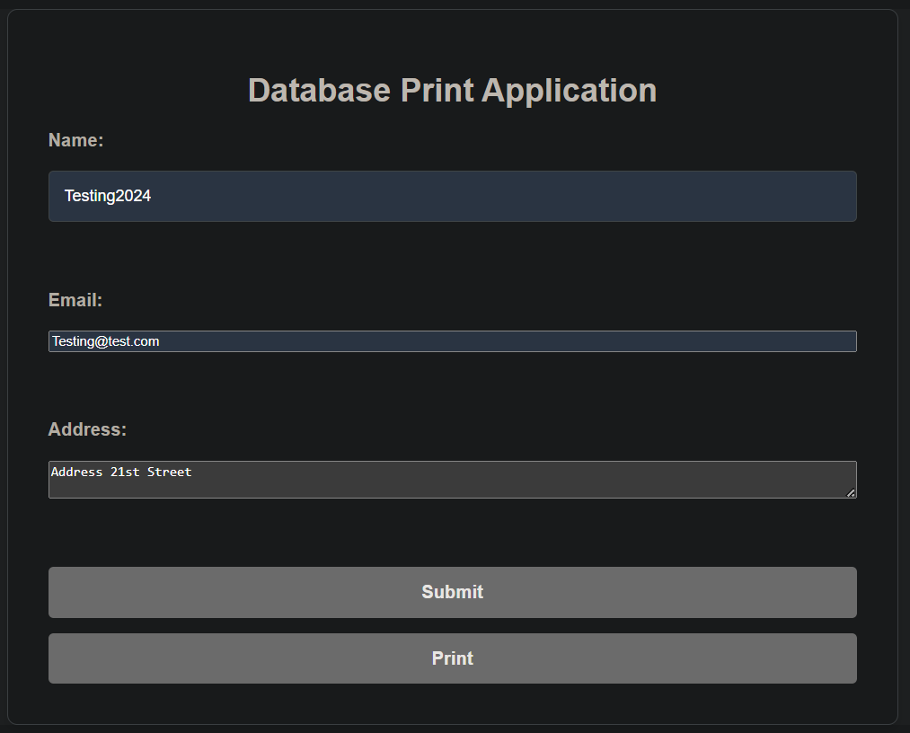

Figure 6, Showing simple project developed in PHP & HTML & CSS

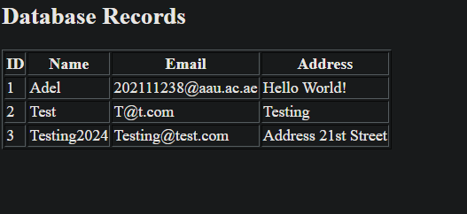

Figure 7, Website after printing the data in the Database Records

For training purposes to get acquainted with PHP we were asked to re-do a simple calculator in PHP but this time separating the code and the connection file into two different files, one for the logic code named “process.php” and one for the connection code named “db.php”. The purpose of this is modularity and security as the connection files store the password for database connection, so these files can be in a safer place and can be easily accessed and repurposed as shown in figure 10.

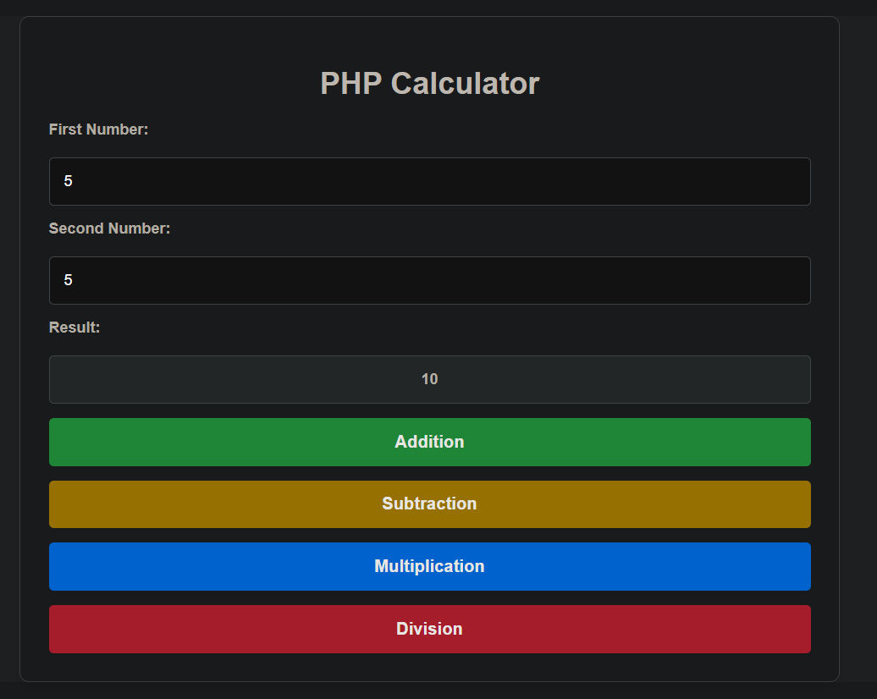

Figure 8, Simple PHP Calculator

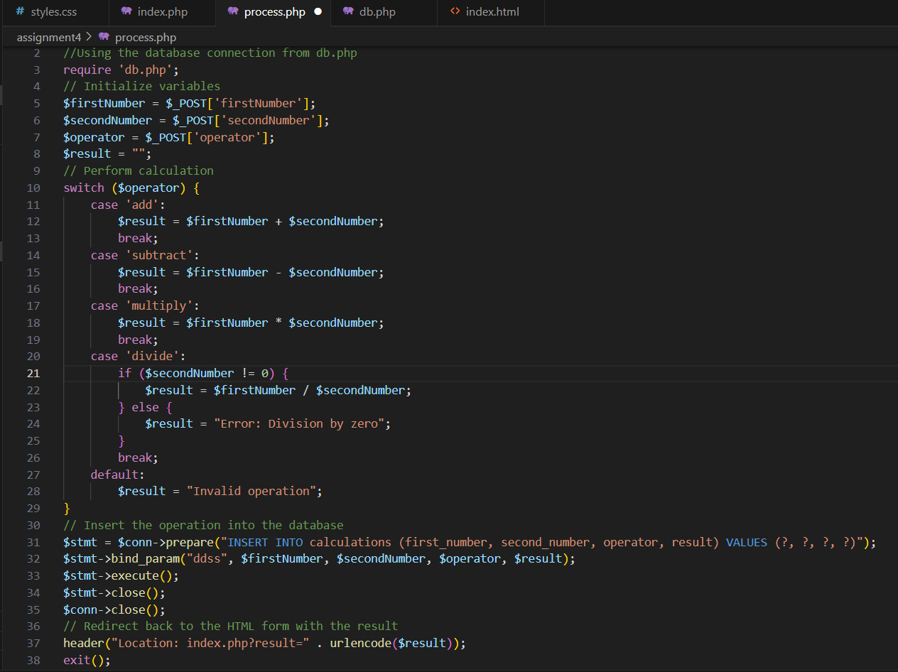

Figure 9, Logic Code for The Calculator

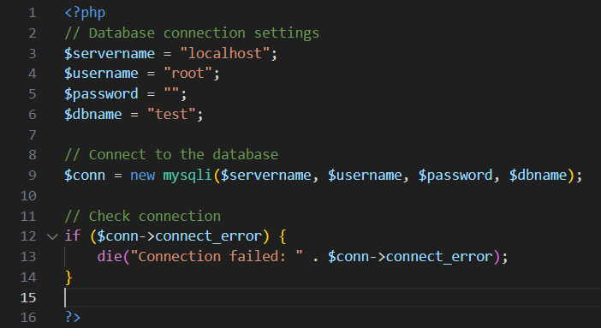

Figure 10, showing the connection file’s code

## **Oracle Project Overview**

The assigned project aims to provide a holistic learning experience about Oracle databases. The project aims to create a library database for a university with the following criterias:

1. Collect requirements and create an ERD Diagram and Schema for the Database
2. Install and create an Oracle database that is compatible with Windows 11 in a virtual machine using Oracle VirtualBox.
3. Create a pluggable database and have it load in read write mode on database start
4. Implement Database Diagram into Oracle Database
5. Create SQL Developer connection to the newly created database.
6. Establish an SQL Developer connection so that mock data can be inserted easily into the database.
7. Perform the Necessary Setup for Developers to Use Oracle APEX for development based on Created Database
8. Create a Workspace and Administrator.
9. Make simple CRUD operations on Database using APEX

Although APEX development itself will not be extensive in this project, the aim is to test functionality and get the basics of developing applications using the platform. The main goal is to create a setup to be used by future developers and interns at Al-Ain University to continue the work later on.

### University Library Requirements As a DBA

After discussions with the university library staff & some of my colleagues, the following scenario has been constructed after approval from project supervisor:

The library system is composed of Employees, students using the library, books in the library, and a library administrator/manager.

Employees are responsible for bookkeeping and handling the students book borrowing and returning and registering all the details on the system and classifying books to a category that it belongs to and they send reminders to the students to return the books on time with the book’s name specifically.

The books have authors and publishers and IDs attached to them and have a single category that they are classified in to be placed in specific sections around the library that they belong to.

The library administrators/managers manage employees and add them to the system to perform their duties. Library Managers are also responsible for acquiring new books and registering them on the system or removing them. If a student doesn’t return a book on time, the administrator will issue a fine to the student after the warnings have been sent by the employees.

### 

### Creating a Database Schema

The initial database design is simplistic in design and focused on separating each entity on its own and where only primary keys link the tables together and adhering to database design principles.

Database normalization is a necessary step to avoid data redundancy and guaranteeing data integrity in any database. It can simplify database maintenance, management and make queries easier to construct for developers. In addition, Normalization avoids anomalies such as insertion, deletion and update anomalies. The following is the schema in tabular format:

Admin:

|  |  |  |
| --- | --- | --- |
| Admin_ID | First_Name | Last_Name |

Employee:

|  |  |  |  |
| --- | --- | --- | --- |
| Employee_ID | First_Name | Last_Name | Manager_ID (FK) |

Student:

|  |  |  |  |
| --- | --- | --- | --- |
| Student_ID | First_Name | Last_Name | Major |

Books:

|  |  |  |  |  |  |
| --- | --- | --- | --- | --- | --- |
| Book_ID | Name | Category | Author_ID (FK) | Publisher_ID (FK) | Supplier_ID (FK) |

Publisher:

|  |  |  |  |
| --- | --- | --- | --- |
| Publisher_ID | Publisher_Name | Publisher_Address | Publisher_Email |

Supplier:

|  |  |  |  |
| --- | --- | --- | --- |
| Supplier_ID | Supplier_Name | Supplier_Address | Supplier_Email |

Author:

|  |  |  |  |  |
| --- | --- | --- | --- | --- |
| Author_ID | First_Name | Last_Name | Author_Email | Author_Address |

Reminder_Records:

|  |  |  |  |
| --- | --- | --- | --- |
| Reminder_ID | Student_ID (FK) | Employee_ID (FK) | Book_ID (FK) |

Borrow_Records:

|  |  |  |
| --- | --- | --- |
| Borrow_ID | Student_ID (FK) | Book_ID (FK) |

Fine_Records:

|  |  |  |
| --- | --- | --- |
| Fine_ID | Student_ID (FK) | Admin_ID (FK) |

The database design was also re-created in an ERD diagram to show the relationships between entities more clearly using draw.io.

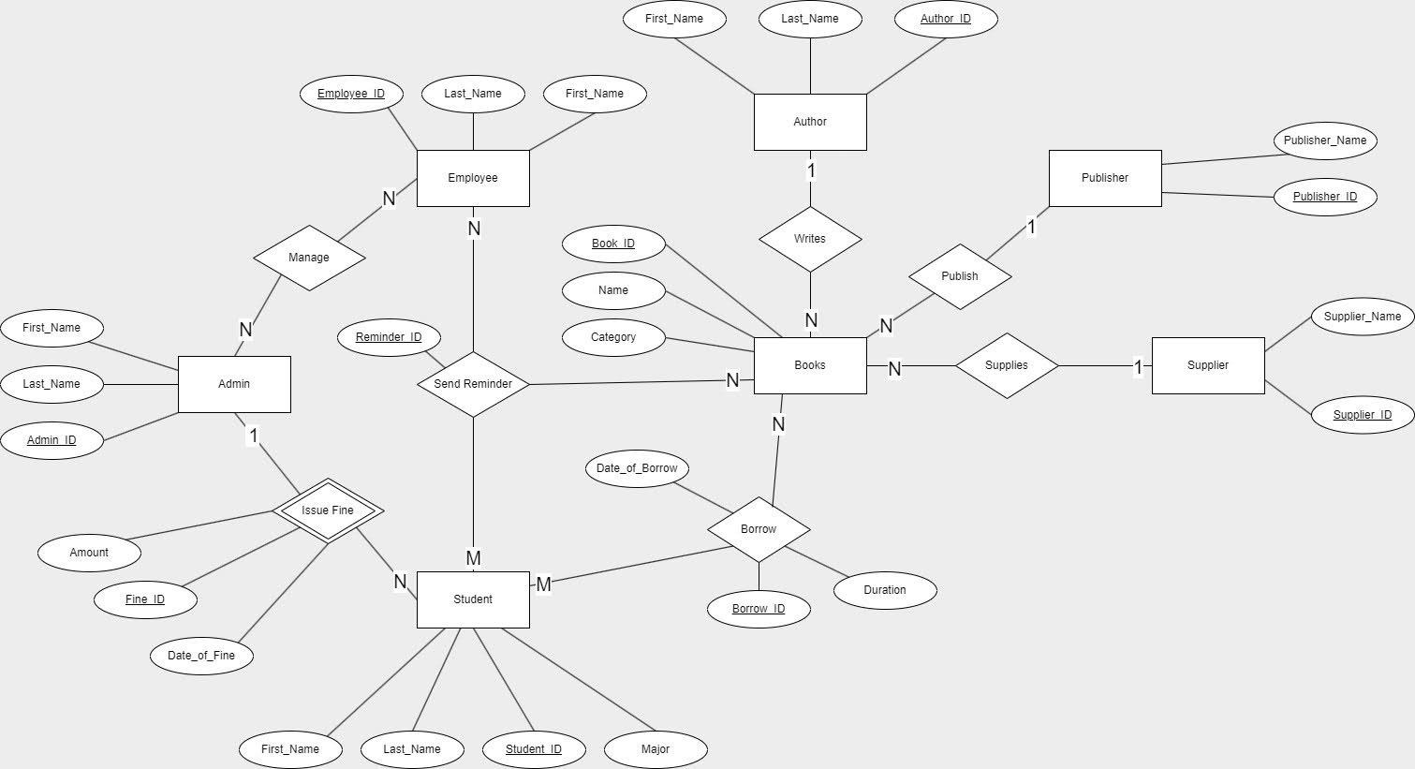Figure 11, illustrates the initial library ER diagram after normalization.

However, after debriefing and showing progress made, a problem was encountered in that the database schema is not appropriate for scalable projects. Three fatal flaws were discovered:

1. I assumed that the database entities would be static, meaning no new types of entities or users would be created.

1. Even after normalization, there is still a lot of repetition of basic attributes such as first name and last name, email etc. for many users in the database.
2. Third flaw was not having any roles assigned to the entities, students do not have the same privileges or access as an employee or library admin.

To fix these problems, a solution was devised where the students, library admins/managers, employees and any future entities (for ex. external visitors not enrolled in the university) could use the system without any major restructuring on the database.

The solution was creating a users table, that would contain any and all users of the system and a role table that stores the different roles (that would also include any future potential roles incase the library had an expansion or different positions of different access levels was introduced), and each different actor or user would have it’s separate attributes in a separate mini table only containing the data it needs.

This also introduced a perfect opportunity to learn and use one of Oracle’s tools for database modelling specifically catered to Oracle’s database infrastructure.

### Oracle’s Data Modeler

Oracle’s data modeler allows you to create ERD diagrams with attributes having specified primary and foreign keys relationship shown more clearly than a simple diagram on draw.io, with each attribute shown how it will be stored in an Oracle Database.

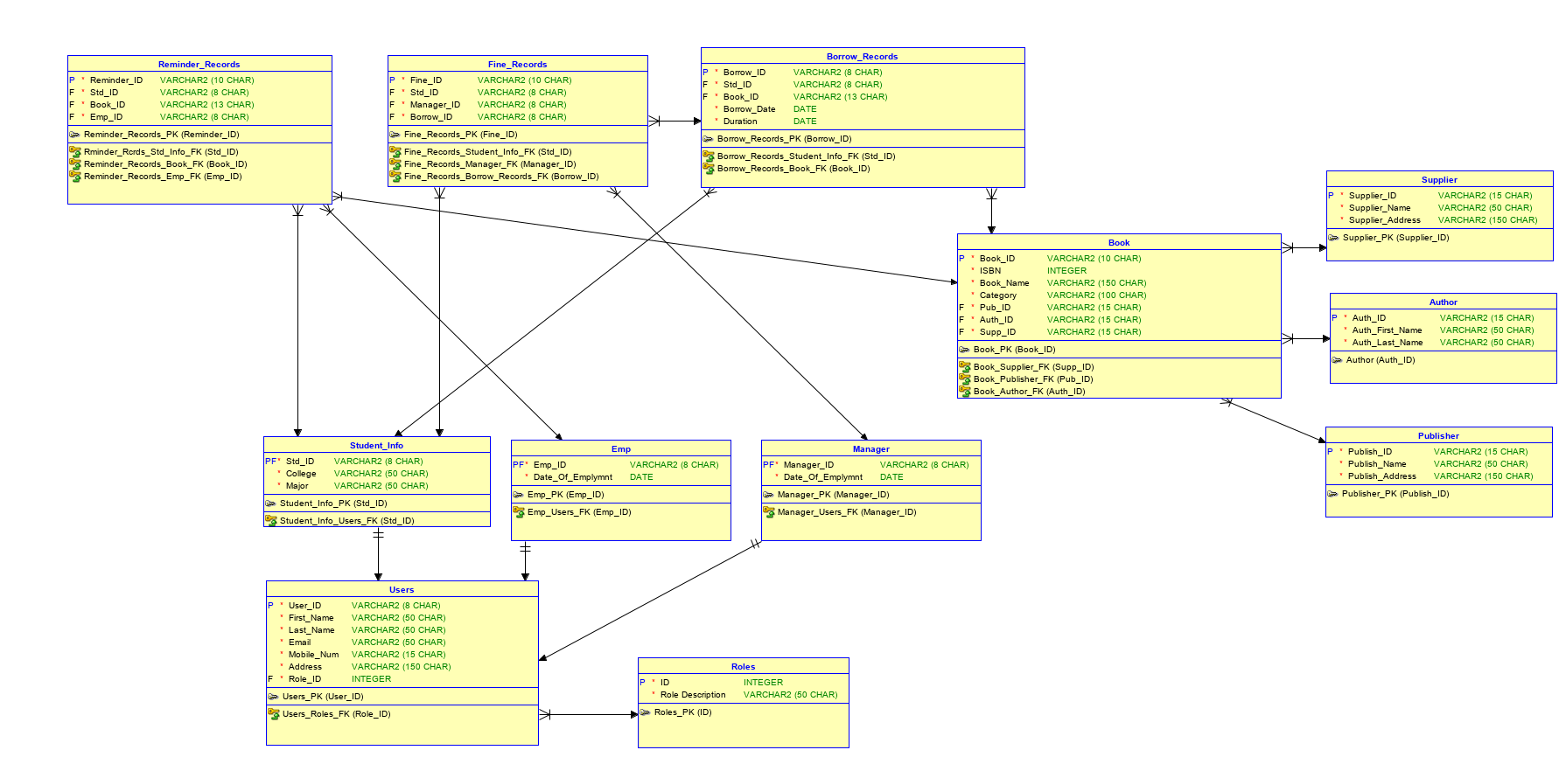

Figure 12, showing the re-designed ERD diagram on Oracle’s Data Modeler

Using the data modeler enabled a better vision of the system as a whole and a better understanding of how attributes should be stored and dealt with in the database to be later implemented in Oracle’s Database.

## **Oracle Database Overview**

According to Oracle’s Database Documentation [1], Oracle Databases since 12c edition introduced an architecture change in their databases, introducing concept database (CDB) and pluggable database (PDB) in their multitenant architecture.

Mutlittenant architecture allows every oracle database to be a container database (CDB) containing one or more user generated pluggable databases (PDBs). The benefits of which will be illustrated after explaining how the oracle multitenant architecture operates.

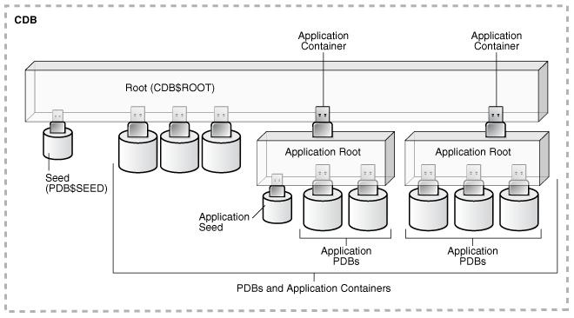

Figure 13, Illustration of a CDB with all of its internal components.

Oracle Databases have the following components: One system container, One CDB root container, One seed PDB only, user-generated PDBs (zero or more than one), and optional application containers (zero or more than one).

System container is a logical container for everything in the database including all PDBs, containers, roots and seeds.

A CDB Root Container (CDB$ROOT) is a collection of schemas, objects, schema objects that all PDBs belong to. It contains oracle supplied system metadata required to manage PDBs such as source code for PL/SQL packages and common users (a default user that is defined and known in every container)

Application Containers operate as a Mini-CDB meant for a specific application within the larger database, but it cannot operate by itself and it requires to be plugged into the root CDB of the database. However, just like the CDB itself it can have PDBs be plugged into it and these are called Application PDBs. [2]

A PDB seed (PDB$SEED) is a “system-supplied template” that is used to generate and create new PDBs in the database.

PDBs contain schemas, objects, and information that is user-generated that is self-contained and managed. They can be migrated, added and removed at will from the CDB root without affecting each other [3].

### Oracle Database Advantages

First is data consolidation, meaning it becomes far easier to relocate data from multiple databases into one, making it easier to migrate data and manage it without altering any schemas or affecting any applications in the process.

Second is better resource management with better flexibility and data management compared to other alternatives such as: virtual private databases, virtual machines or placing multiple databases. This is due to its architecture and encapsulation and ease of migration for data.

Third, easier management of a database. This is achieved by the multitenant architecture that provides an easier migration between servers and protection against data corruption and ability to have actions be done to a specific PDB (upgrades, reverses, etc) without affecting the other PDBs. A Database Administrator can assign an administrator to a specific PDB with limited privileges resulting in better security as well as many other benefits [4].

### Virtual Machine Setup

Virtual Machine (VM) was set up using Oracle’s Virtual Box with default settings using Windows 11 Pro, as it is compatible with Oracle Database 19c [5]. Windows 11 ISO is taken from Microsoft official website and was allocated sufficient resources to operate both Windows 11 and Oracle Database 19c and Oracle Apex with 8GB of Ram, 256 MB of Video Memory and 4 CPU Cores, and 80 GB of Storage space. The rest of the settings were kept as default.

Precautions had to be taken in order to ensure adequate performance and not affect the VM’s integrity or run into any unforeseen problems that are caused by Windows default virtualization being enabled or some Windows systems that could cause problems. The following is recommended to be disabled according to the user Scott Gus on Oracle’s virtual forms: Hyper-V, Memory Integrity, Secure Core, CredentialGuard, Windows Defender's Core Isolation, Memory Protection [6].

### Database Installation & Configuration

In order to successfully install Oracle Database 19c, the following prerequisites are needed.

* C++ packages from Microsoft:
  + MS Visual C++ 2008 Redistributable Packages
  + MS Visual C++ 2012 Redistributable 11.0.61030
  + MS Visual C++ 2010 RUNTIME LIBRARIES WITH SERVICE PACK 1 x64
  + MS Visual C++ 2010 RUNTIME LIBRARIES WITH SERVICE PACK 1 x86
* Java JDK 12 (JDK 8 or above in general) and setup with default settings with installation in C:\ drive
* Set the path and environmental variables and PATH

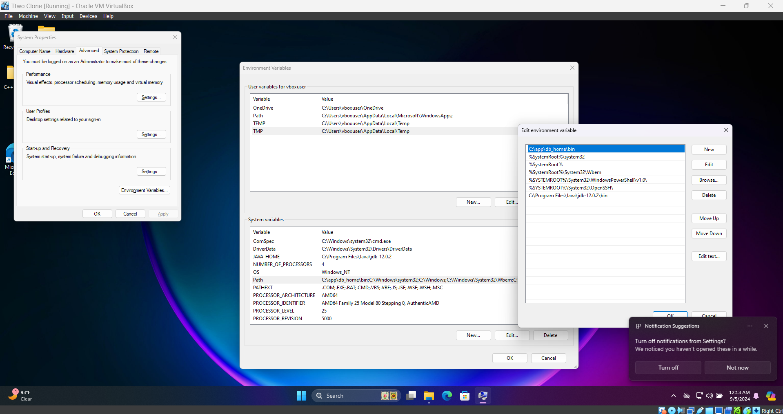

Figure 14, Setup for environmental paths for both database and java.

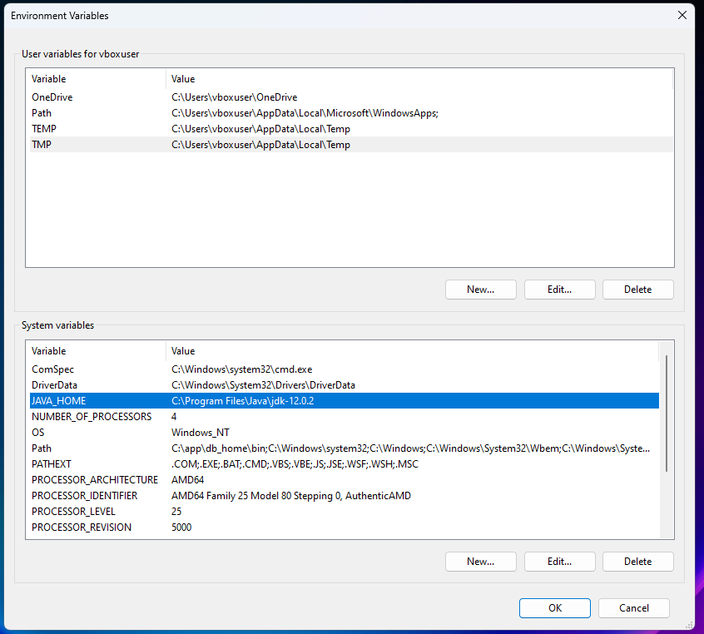

Figure 15, Setting up the environment path for Java 12.0.2.

### Database Installation Process

Copy the zip folder for Oracle DB 19c (Named WINDOWS.X64_193000_db_home) and create a new folder named “Oracle” on C: Drive (worth noting to keep consistency with everything being installed into proper folders and having proper folder naming to avoid errors) and inside of it create a folder named “Oracle DB” to store Oracle Database 19c and paste the zip folder into it and extract it Rename the extracted folder db_home.

It’s worth noting that for testing purposes **Oracle1234** will be the password for almost everything here except for Oracle Apex Which will be Oracle_1234. Keep in mind all commands will also be run in terminal or programs will be run as administrator as well.

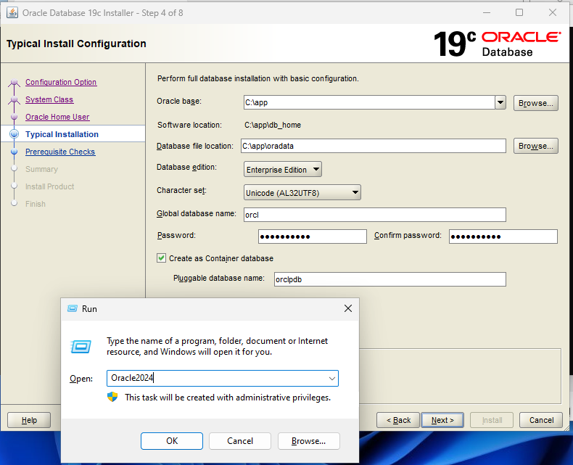

Figure 16, showing the configuration of the database, creating a container database named “orcl” with a pluggable database named orclpdb.

### Creating a new PDB

Creating a PDB can be done through the terminal with SQL commands through Oracle’s SQLPLUS, another solution is to use Database Configuration Assistant (DBCA) with a GUI which has been used for this project as the design is more intuitive and allows for better .

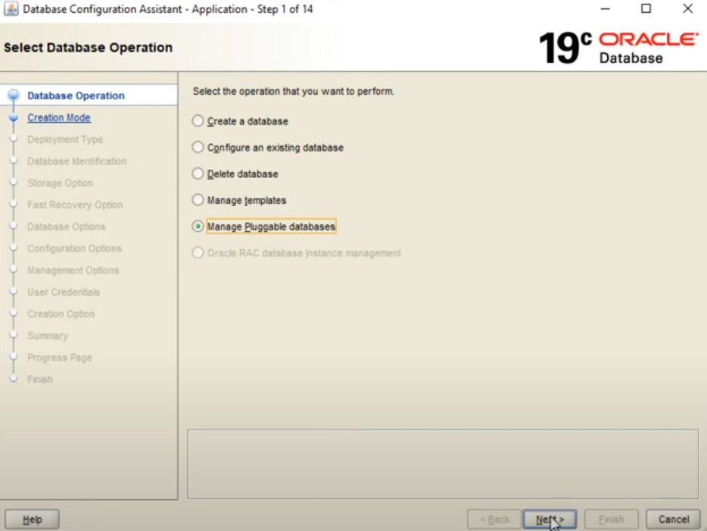

Figure 17, shows the first step to create a PDB for our library database.

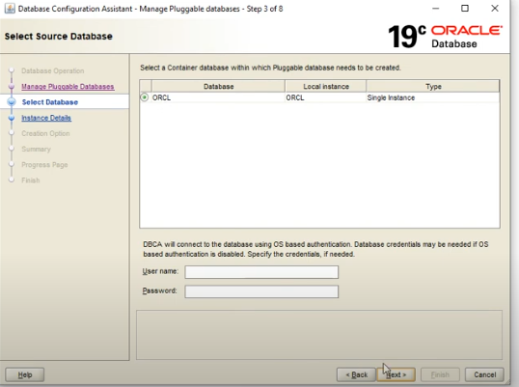

Figure 18, shows which container database is selected.

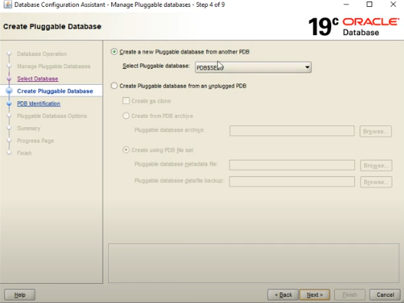

Figure 19, illustrates the pluggable database template used pdb$seed (oracle default pdb template)

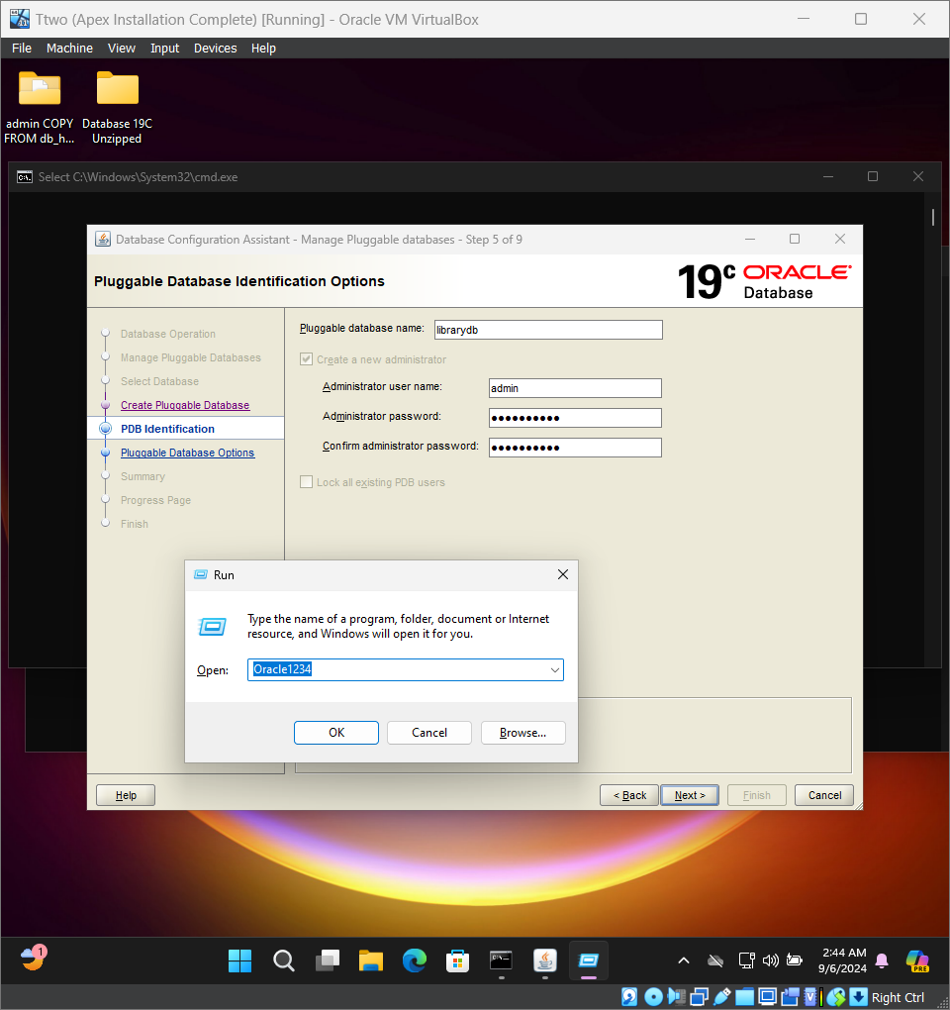

Figure 20, showing PDB Details & Credentials with password shown in the Run Window

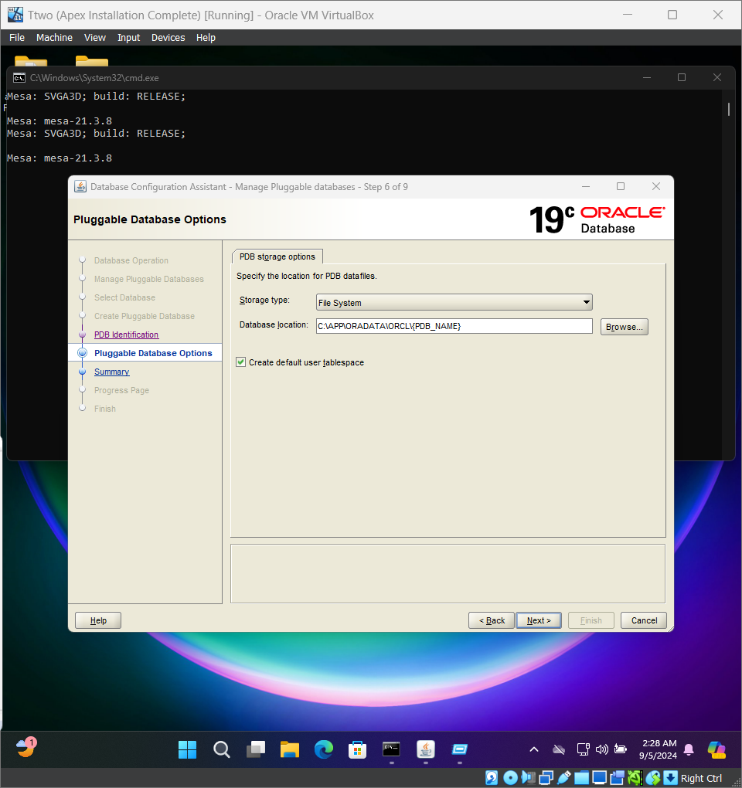

Figure 21, Showing Database Location and Method of Storage for Database

After this step, the pluggable database will be successfully created and the DBCA program will terminate and the next step will be to verify that the pluggable database has been created using Oracle’s SqlPlus through the command prompt.

### 

### Configuration of Networking Files

In order for the newly created PDB to function properly, we need to provide it with networking in order to connect to it properly.

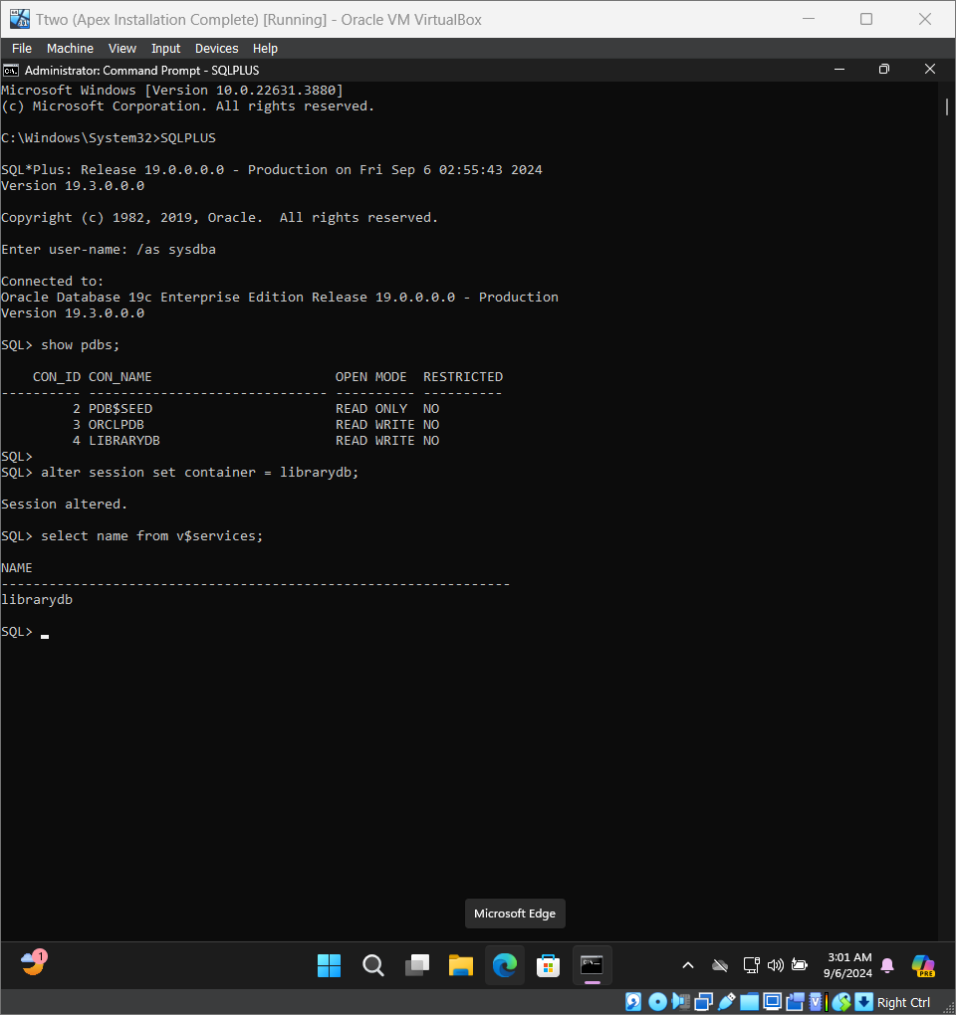

Figure 22, Showing LibraryDB as a pdb in the container and it’s service name

The figure 22 shows the service name which will be used to set up the network configuration of the database to allow for connection from SQL developer later on.

Now that we have created and verified the successful creation of the PDB for our library, we need to modify the network files so that we can connect successfully and create tables and enter data for the library database.

Oracle’s databases operate on their own networking, requiring modifications to said files in order to connect to the pluggable databases, create tables, enter data and conduct other operations on them.

Oracle’s database has SQLNet or Net Services that it operates its connections using. For the purposes of this project only the tnsnames.ora file is dealt with. The tnsnames.ora file is responsible for client side network configuration [7]. It is necessary to modify and update it because each PDB has a separate identifier and services that need to be routed towards to ensure successful connection to the PDBs (see figure 23 with librarydb service name).

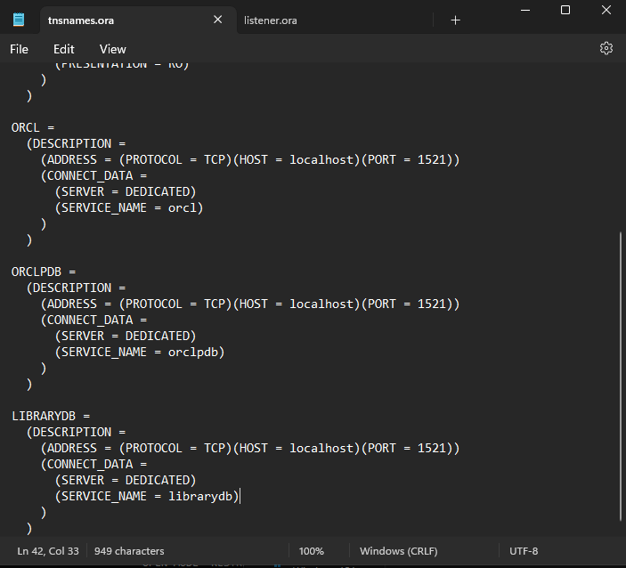

Figure 23 showing tnsnames.ora file & additions made to it at the end (LIBRARYDB).

The additions to the tnsnames.ora for the librarydb for successful connection. The “LIBRARYDB”, “ORCLPDB”, “ORCL” are a network service alias and are used by clients when they are connecting to the service or PDB.

“(DESCRIPTION = …)” is for details to connect to the oracle database and it’s the wrapper for all the components required to connect to the database.

“(ADDRESS = (PROTOCOL = TCP)(HOST = localhost)(PORT = 1521)” is the network address that specifies for the client where to look for the Oracle service (PDB or otherwise). “PROTOCOL” specifying which protocol is used. “HOST = LOCALHOST” refers to where the host is running the database, which in this case, is on the same machine that is installed on it. However, if it was any other machine the database is hosted on, it would be replaced by an IP Address of that machine. “PORT =1521” refers to the port used for connection, Port 1521 is a TCP port number and it is also the default port for oracle database connection which can be changed. (CONNECT_DATA = …), it contains the connection data for the oracle service and tells the oracle listener (used by the client) what service the client wants to connect to. (SERVER = DEDICATED) tells client which server connection to use which could be dedicated (for each client connection, it spawns a dedicated server process) Or shared (used when many client connect simultaneously and processes are shared among multiple clients for better resource management)

In summary, any client that specifies that they wish to connect to Library Database with the service name of librarydb will connect using TCP Protocol on the localhost (using IP 127.0.0.1) and using port 1521 and it will create a dedicated server process for each client connection to the database.

### Navigation to & from PDBs and Setting to Boot-Up on Default

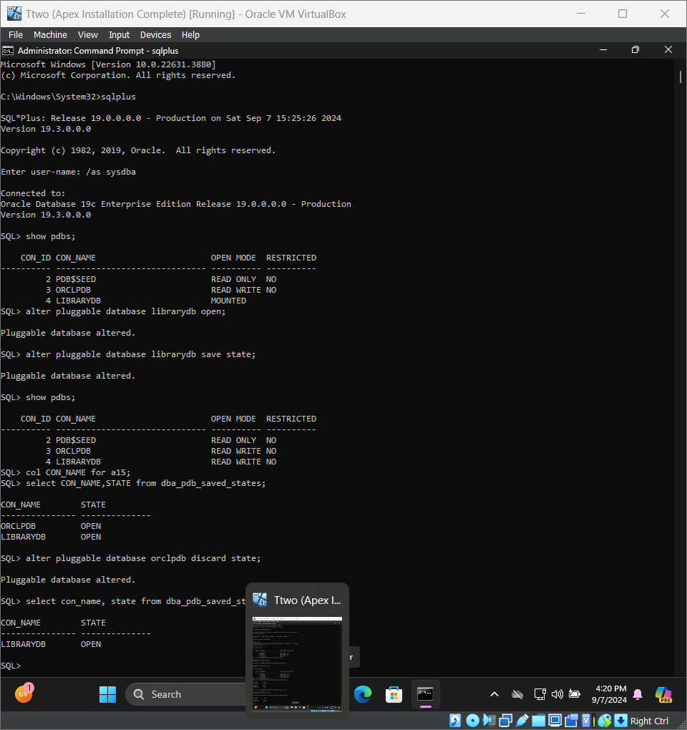

Figure 24, showing sql commands to open up pluggable databases & set librarydb to open mode and save its state on bootup for next time.

The following is an explanation for figure 24 and the commands used in the figure:

* “show pdbs;”: command to show pluggable databases
* “alter pluggable database librarydb open;”: to open it in read and write mode
* “col CON_NAME for a15; ”:

This command is to format the display of the next query results, “col” is shorthand for column and “con_name” is short for container name (both PDB & CDB) and it’s the column being formatted. “for a15”, a stands for alphanumeric data and 15 is for specifying 15 characters as the width of the column.

“select con_name, state from dba_pdb_saved_state;”: shows pdbs that have saved state.

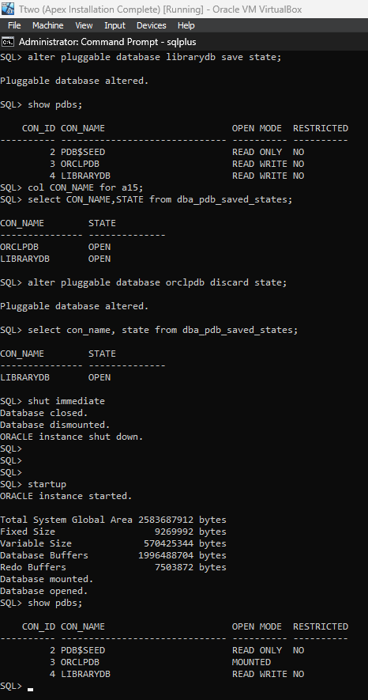

Figure 25, showing the pdb librarydb in read & write mode after shutting down the database.

As the figure 25 illustrates, it shows the database successfully saved the state of the library database while discarding Oracle’s default pdb (orclpdb) and only leaving librarydb in read and write mode.

### Creating SQL connection in SQL Developer

SQL Developer is an IDE created by Oracle for Database management that can be used for running SQL Queries easily and designing database schemas among other tasks in GUI Interface.

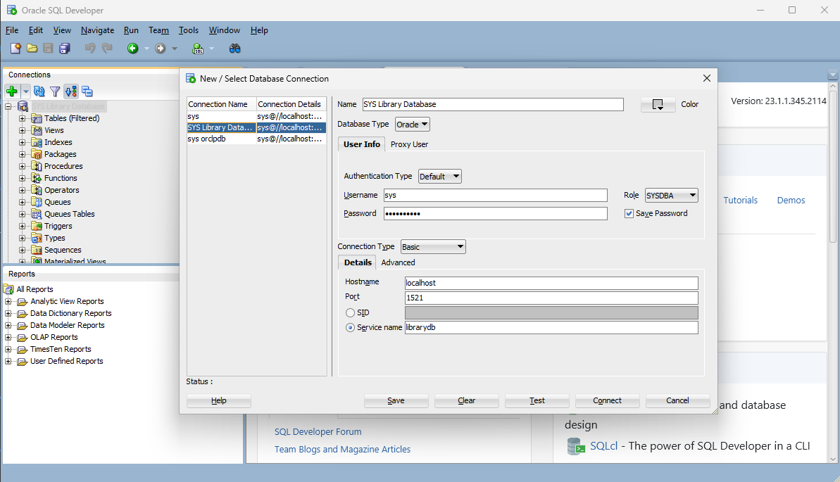

Figure 26 shows the SQL Developer tool while connecting to the library’s PDB.

Connection is done through the plus sign under connections in the GUI, with a name provided to the connection and authorization done with the role of sysdba with the username sys and password Oracle1234 as a user with sysdba privileges. The connection being done with default port on 1521 as was shown previously in the tnsnames.ora file and host name being localhost (since our virtual machine is the one hosting the PDB and we are connecting to it) and service name being as shown previously in tnsnames.ora file as librarydb.

In addition, a connection was made to the CDB to unlock an additional account which will be used by Oracle Apex and the default orclpdb for testing purposes.

### Implement ERD using SQL Developer

The schema for the database will be created using a new user to avoid any pollution/damage to the oracle schemas and internal tables that are used by database, as such all new tables that will be created will be done using the new user who will carry all the tables called “LIB_ADMIN” with the password of Oracle1234. Every user has their own schema and it is considered best practice to create a user for every new schema created.

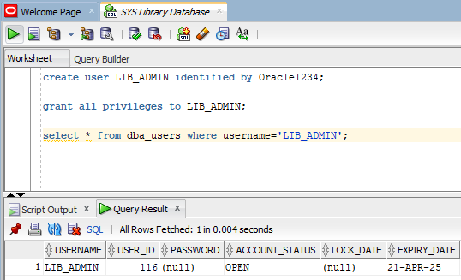

Figure 27, showing the new user to hold the library schema being created successfully.

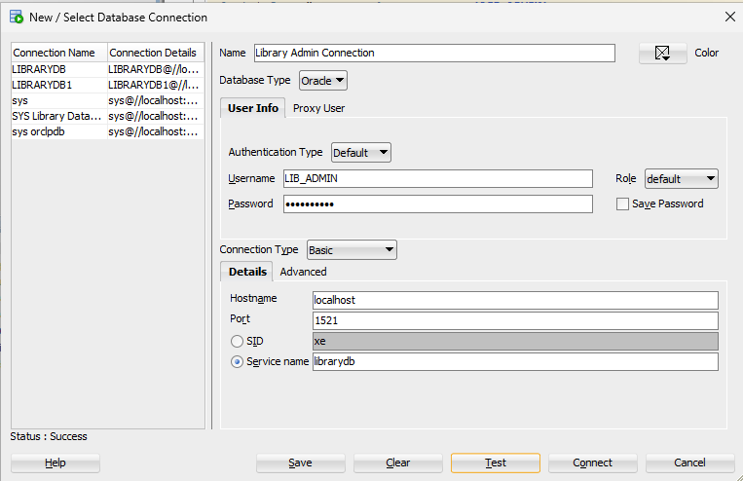

Figure 28, showing database connection in SQL developer.

Implementing the diagram in Oracle Database can be done in multiple ways, you can traditionally write the SQL code by hand and try to meticulously follow the guidelines and best practices. But Oracle has another tool to use which is Oracle’s SQL Developer Data Modeler, which you can diagram on and then later convert the diagram to SQL code to be implemented in the database.

### Inserting Data into Tables

Dummy data that I have made will be used for this project and then inserted into the database. While most databases such as PostgreSQL, MySQL, SQL Server have a unified traditional way of inserting data in bulk (multiple rows into the same table), Oracle Databases operate differently.

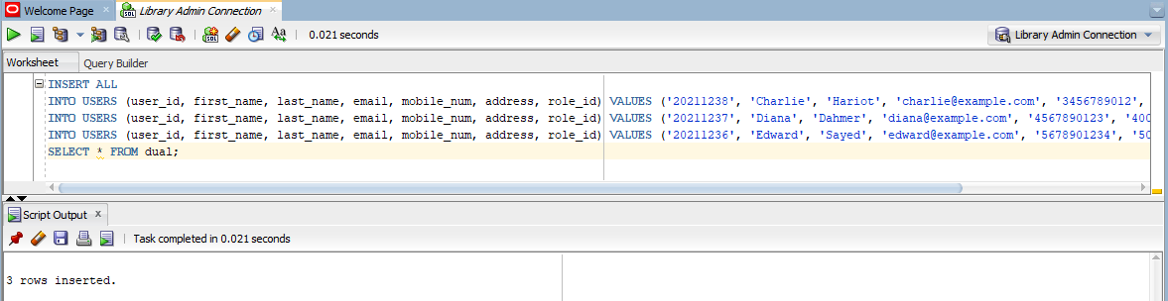

Figure 29, showing bulk data insertion method.

While the query is self explanatory, the last statement: “SELECT * FROM dual;” is required in order to execute the previous SQL statements successfully. Because the structure of this statement is designed in such a way that it pulls data from the selected table and inserts it into other tables. Since this is not our goal and we exclusively want to insert data into the “USERS” table, we specify a dummy table in oracle called “dual” and run our previous statements without inserting data from any other table. This is the usual workaround solution for oracle databases.

It’s generally preferable to insert data in bulk to save time and to make sure that if, for any reason, one statement fails, you can locate the statement and fix it and then run the code. This is done to avoid accidental data replication by possibly running some statement twice when inserting data. Rest of the mock data was inserted using this method.

Other queries are generally similar in Oracle’s SQL to traditional SQL. However, this was the biggest divergence I've found while working on this project.

## **Overview Of Oracle APEX**

Oracle APEX (Application Express) is a low code development platform that enables you to build scalable, secure, enterprise apps that are easy to deploy online for audiences worldwide. Capable of working on cloud and connecting to the database of any kind or natively on devices using the databases installed on them or even simple spreadsheets. Generating applications using default templates and making it easy to modify and build from scratch while still allowing for customizability in the application design and development.

### What is the Architecture Used?

APEX architecture is a three-tier web application architecture consisting of the client, the middle tier ORDs (Oracle REST Data services), and Database Tier. These systems are called the Oracle RAD Stack.

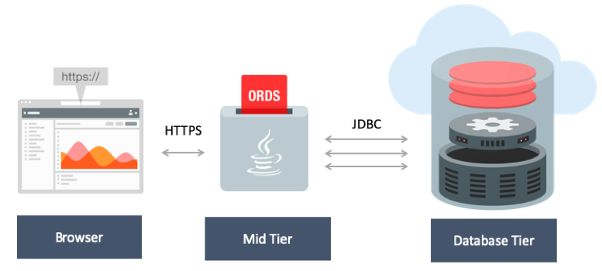

Figure 30, Illustration of Oracle RAD Stack & Three Tier Architecture.

### What is the RAD stack ?

RAD stands for REST Data Services (R), Oracle’s APEX (A), Oracle Database (D). This stack provides all the components needed to build scalable web applications without needing additional parts with Oracle APEX & ORDS being pre-existing features of Oracle Database since 12c and above.

### Oracle RAD Stack in Action:

The client would access the web app through a url, where the ORDs would request/submit data to the database tier. The database tier has the data schemas which has the metadata necessary to operate Oracle APEX and the created application and Oracle APEX Engine that is inside the database backend, The Oracle database operates on PL/SQL that is which is a procedural programming language that is based on functions that are executed in sequence and SQL.

### Installation of Oracle Apex on LibraryDB PDB

Apex 20.2 is used in this project, it is compatible with Oracle Database 19c. Apex is downloaded from Oracle's official website. In order to install on Oracle Apex and be able to use the library PDB, it is necessary to open the cmd as admin and navigate in the cmd to the apex files and open SQLPLUS and then connect to the pdb and install Apex on it specifically.

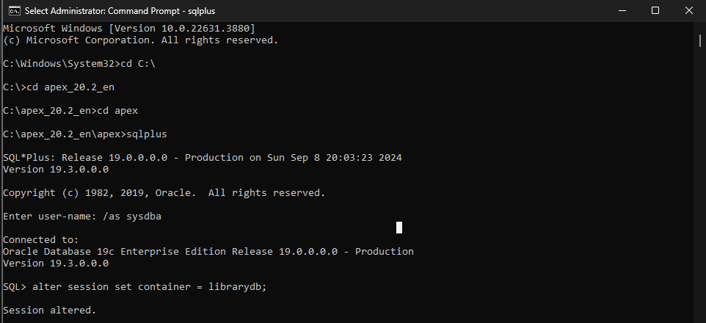

Figure 31, showing navigation to apex files & setting session to librarydb.

When installing Oracle Apex, there are three tablespaces (tablespaces is a term used to refer to a storage unit that can store database objects such as tables for example [8] that are required from to provide in order to install Oracle Apex have it’s files stored properly as per Oracle Apex installation manual [9]:

1. Tablespace for Apex users schemas and objects be stored
2. Tablespace for Apex user files specifically
3. A temporary tablespace for temporary tablespaces or groups
4. Images for Apex images and/or resources.

@apexins.sql SYSAUX SYSAUX TEMP /i/

The command to install was the default one as provided by the Apex installation manual but they can be modified according to the installers desires.

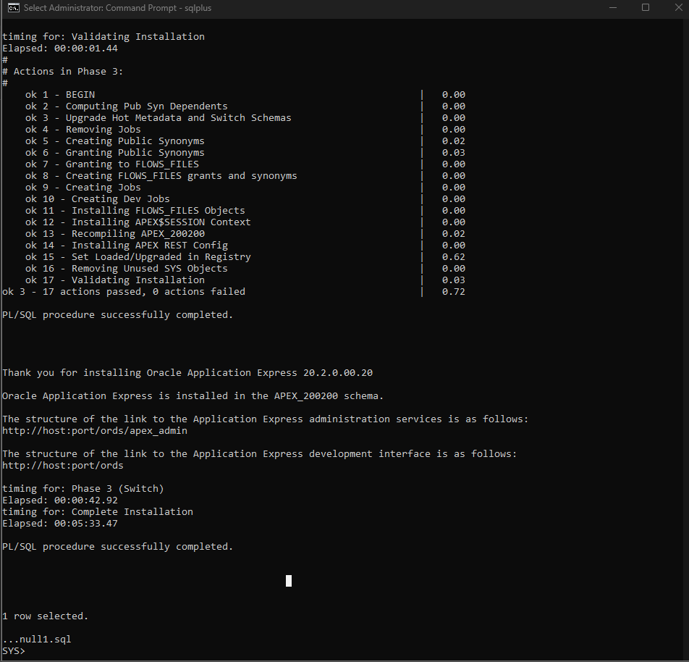

Figure 32, Shows the successful installation of Oracle Apex

Now to create an admin user and their password through an SQL file called apxchpwd.sql (Apex change password sql file).

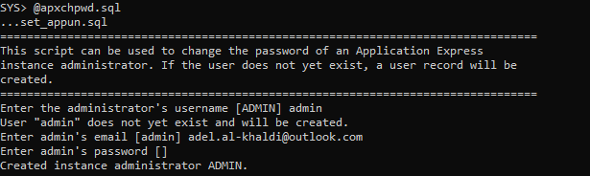

Figure 33, Showing Apex Admin creation with password of Oracle_1234

Another Script to run is apex_rest_config which is used to setup the REST config users and adding their passwords (which is Oracle_1234)

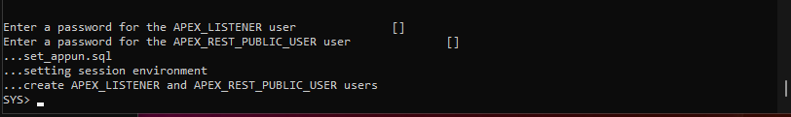

Figure 34, showing successful creation of the users with password Oracle_1234.

While the users (apex_200200, apex_instance_admin_user, apex_listener, apex_public_user, apex_rest_public_user)and setup is successful, we still need to unlock the users and change some of their passwords and that will be done through SQL Developer using the SQL code:

alter user (apex user) identified by Oracle_1234 account unlock;

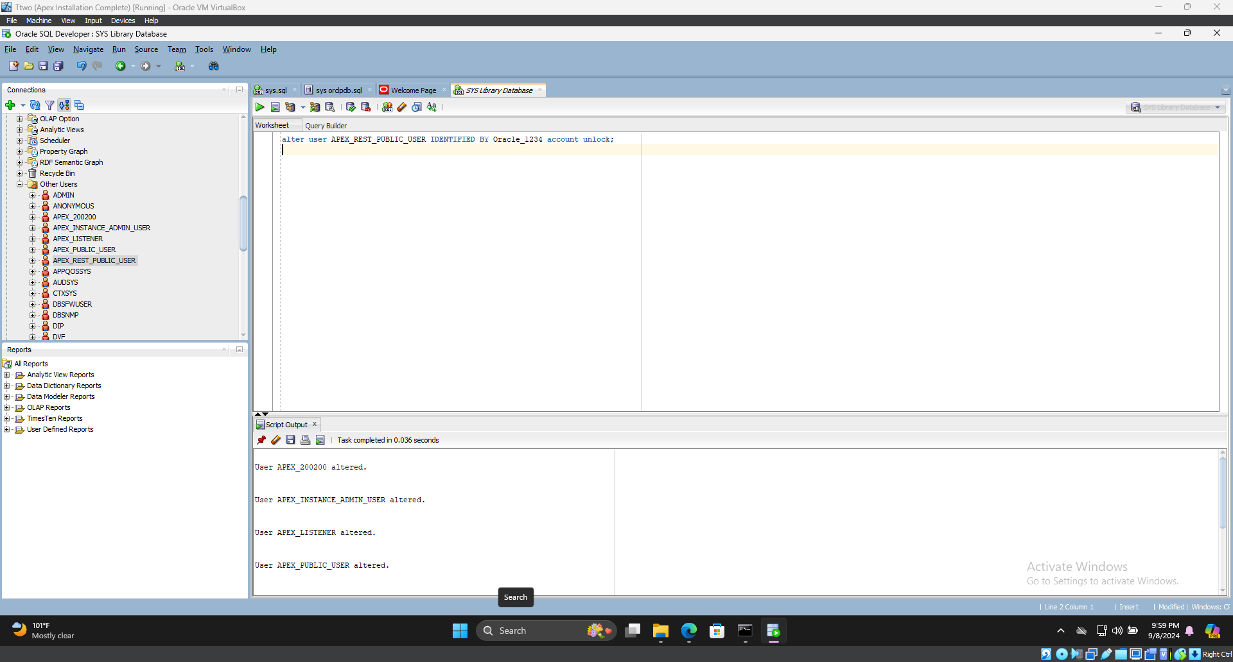

Figure 35, Shows command used and results from unlocking the account.

The final account to unlock is anonymous which can be unlocked by connecting to the CDB instead by left clicking on the pre-existing connection that was made to the CDB which is sys.

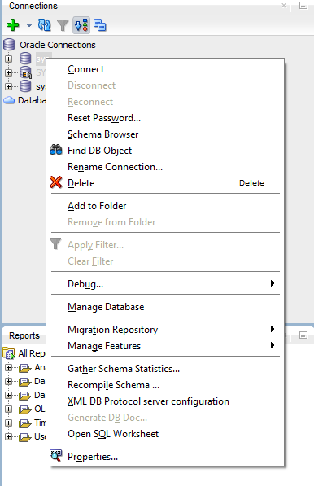

Figure 36, Showing how to switch connections between PDBs and CDB as well.

After connecting to the CDB successfully, all that is left is to alter the anonymous account with the same command used previously but this time we replace the user account’s name with anonymous.

## **Backend Setup for Oracle APEX**

### ORDS & Tomcat, Summary & Interaction

To facilitate the hosting of applications for the development, Tomcat Apache is a web server that was used for its lightweight and compatible and easily configurable with Oracle Databases. Tomcat facilitates the deployment of ORDS, which acts as a bridge between the database and web applications. When configured properly on Tomcat, ORDS is deployed as a java servlet in Tomcat. Tomcat handles HTTP requests from the users and routes them to ORDS and it handles it as SQL or PL/SQL to interact with the database.

### 

### Apache Tomcat Setup

Apache Tomcat is an open-source web server and it is used for Java-based applications. Built on Java technologies, Tomcat acts as a connector between the servers and the java applications facilitating lightweight management & processing of client requests. It is easy to install and configure and compatible with Oracle Database 19c [10].

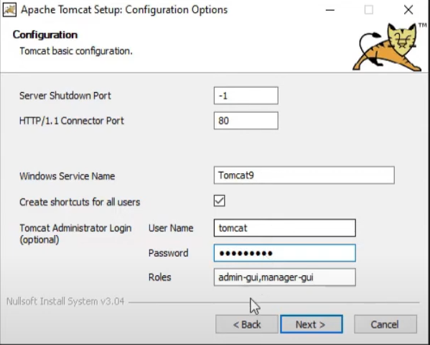

Figure 37, showing configuration of tomcat during installation.

After the installation & configuration of Tomcat, Copying the ords.war file to the tomcat web app folders, afterwards it has to be installed on the server and then configured for Oracle Database itself.

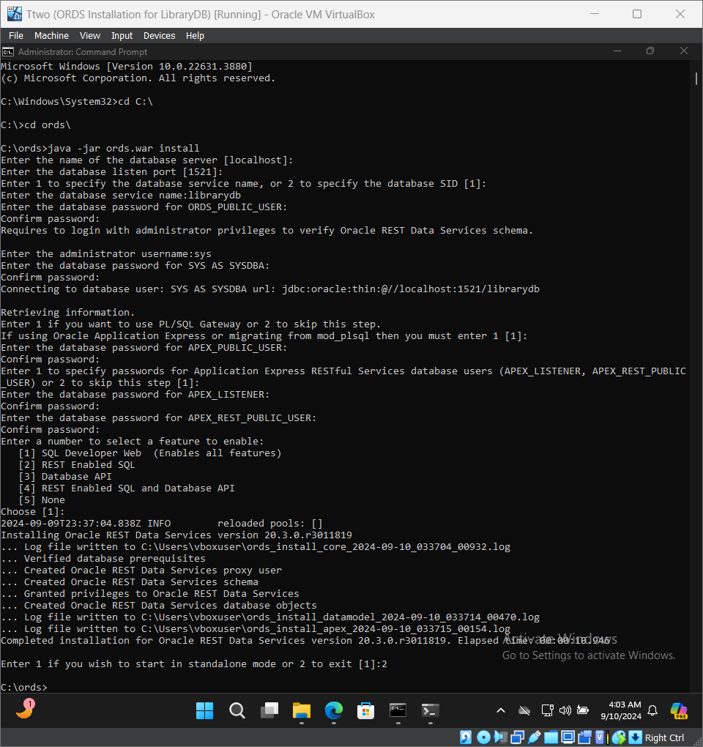

Figure 38, Showing Proper Installation of Oracle Apex With Final Prompt.

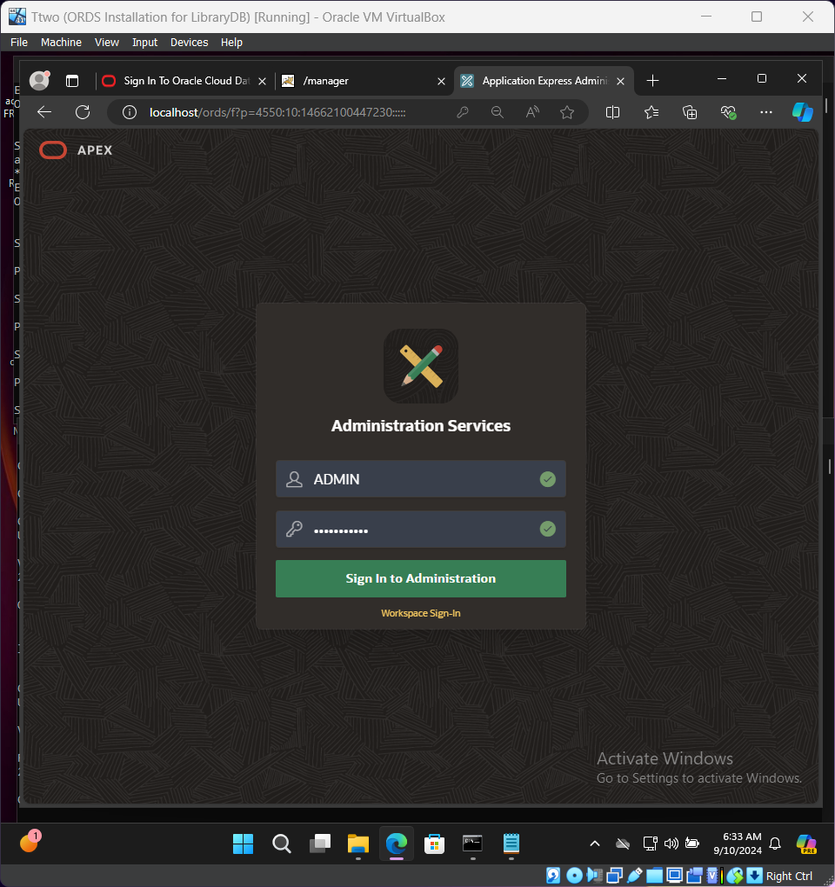

Figure 39, Sign-in page for Apex using username and password setup during installation of Apex showing after successful installation & configuration of ORDS.

### Workspaces in APEX

Workspace is a logical area in Oracle Apex that allows users to create and run APEX applications. Each workspace is associated with a database schema acting as a source for the data, with each workspace having its own users and developers and administrators.

Figure 40 showing the workspace name assigned and description for the workspace. Figure 41 shows the next step of workspace creation by assigning a pre-existing schema to the workspace which is Lib_Admin, which was the user that was created for carrying all the library tables and data. The next figure 42 creates a workspace administrator that would be able to add developers and also used to develop a simple prototype for this project.

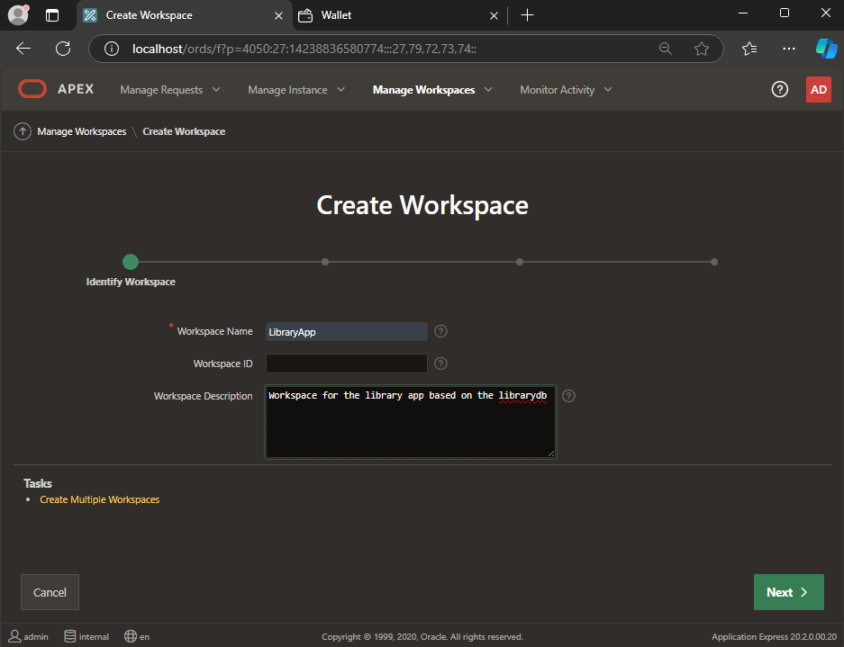

Figure 40, First step into creating a workspace in APEX.

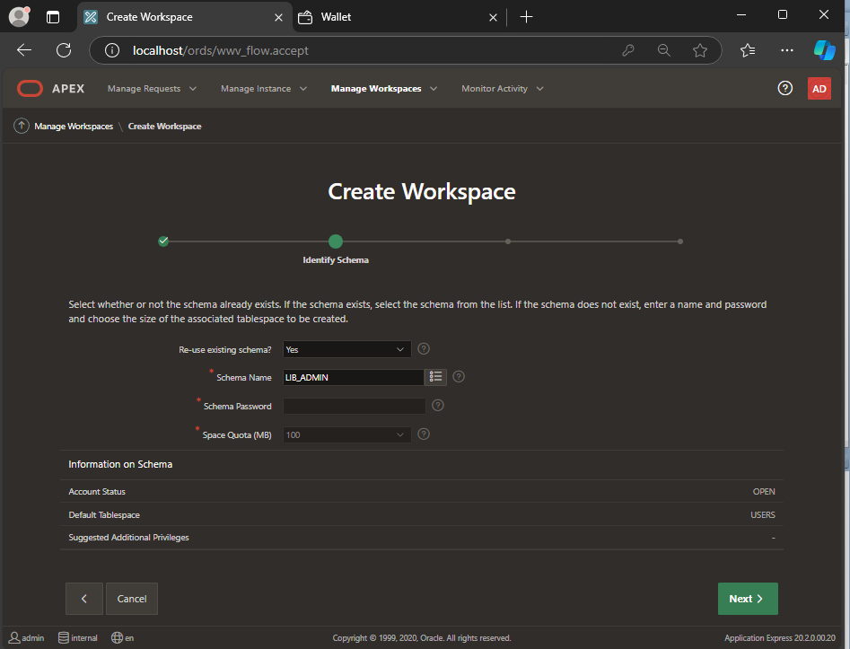

Figure 41, Oracle Workspace being created.

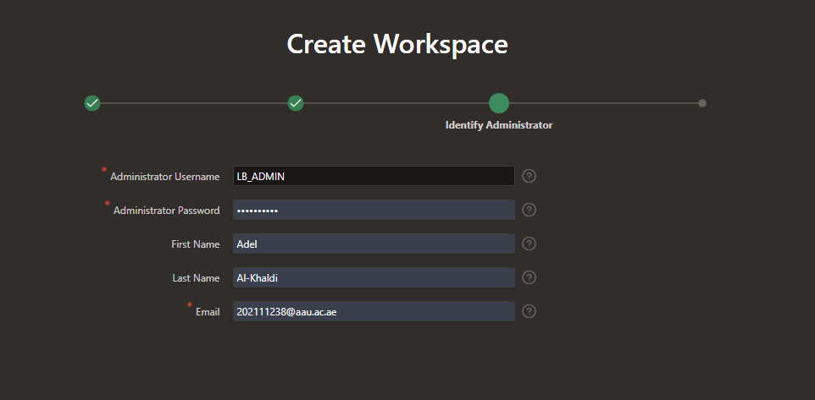

Figure 42, Creating a workspace administrator.

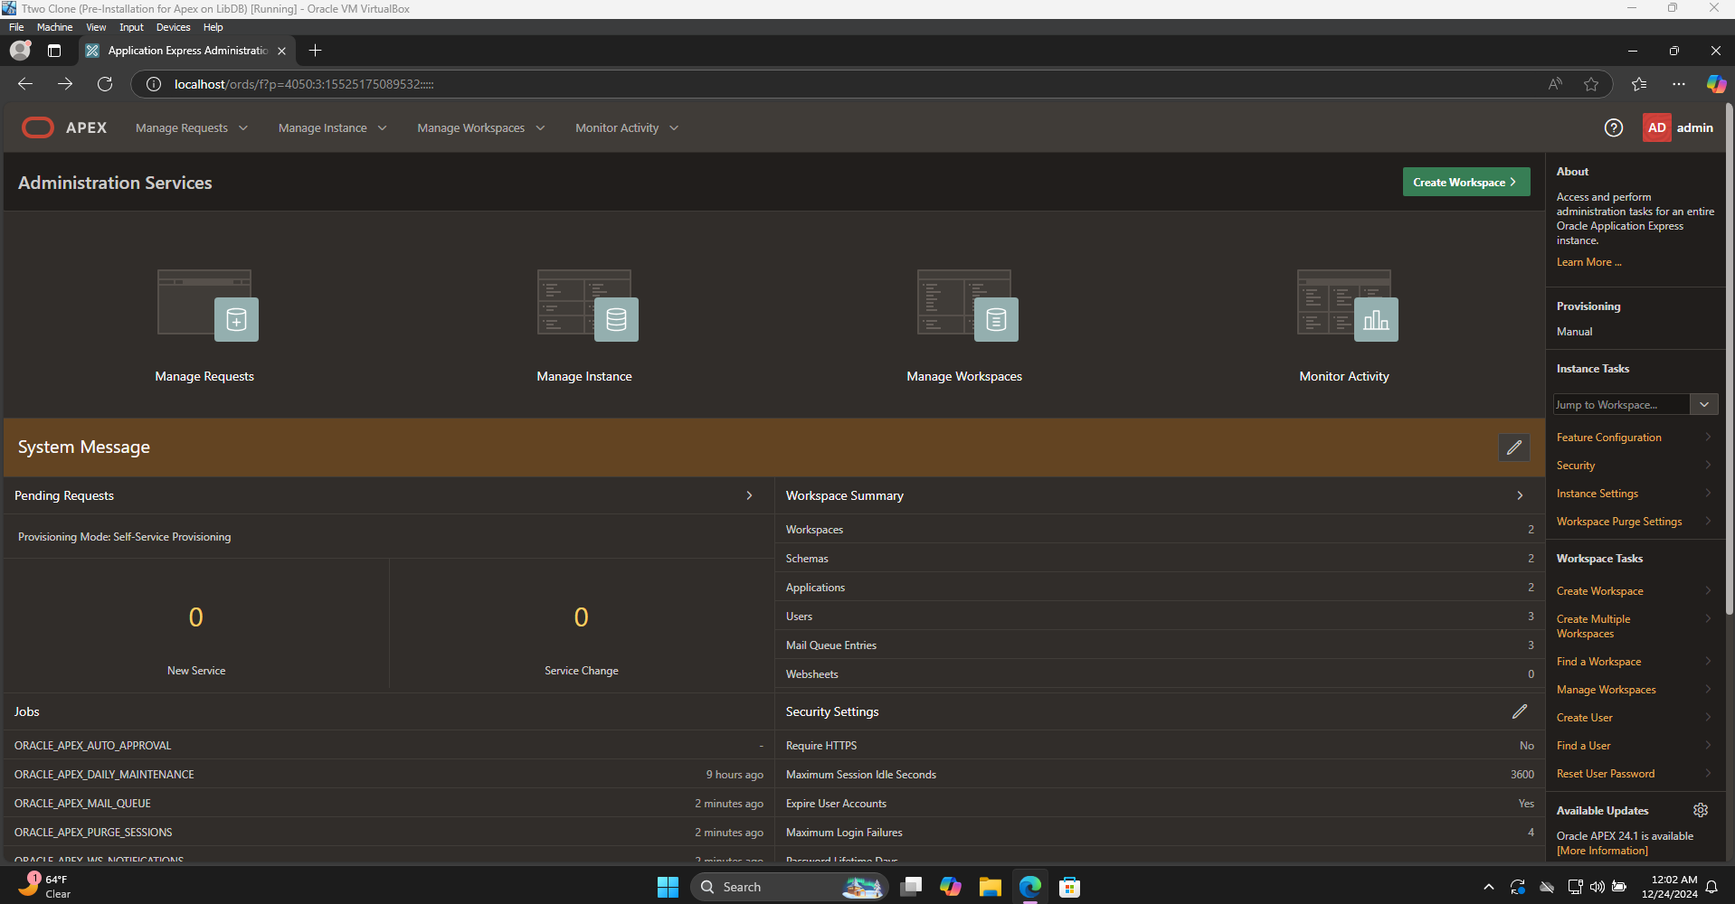

Figure 43, Completed workspace creation.

## 

## **Simple CRUD Operations Using APEX**

Simple application through oracle’s APEX to verify the functionality of the APEX itself and test if CRUD operations are functional and to illustrate the features of oracle APEX.

### Creating an Application in APEX

After successfully creating a workspace, we log out of APEX and sign back in as the workspace administrator and then create an application from the Create button on the Apex App Builder (as shown in figure 44) and create a new application based on the library schema created earlier in the project.

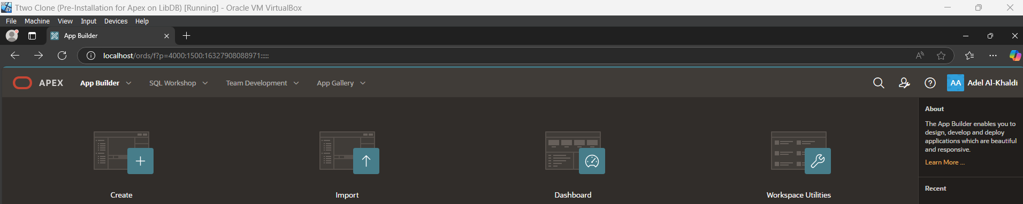

Figure 44, Showing the create button on far left in APEX

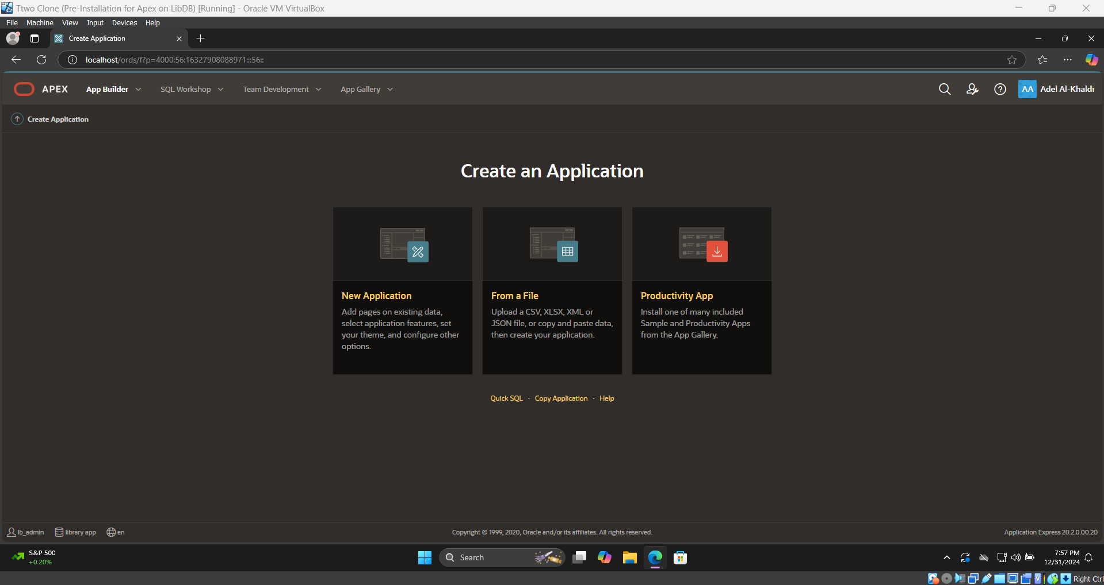

Figure 45, creating a new application using APEX’s wizard for functionalities testing.

### Creating a Report with Form Page In APEX

The simple UI for APEX allows you to create a page in the application. The goal is to create a simple page that allows you to add a user to the user table in the schema. This is done by clicking on the “Create Page” button, then selecting “Form”, then “Form with Report” as shown in figure 47 and 48 respectively.

Afterwards the wizard for creating the pages as shown in figures below and hiding of ROWID which is APEX’s default primary key, which enabling is necessary to make modifications directly on the report which affects the data in the database. However, I was asked to change it to not allow modifications in figure 50, I’ve changed it to classic report and disabled showing ROWID. Final result shown in figure 51 and then adding a user to the library system in figure 52 to the database. To make sure that the user is created and inserted into the database, we have to check the database using SQL developer one last time to verify that APEX is indeed functional as shown in figure 54.

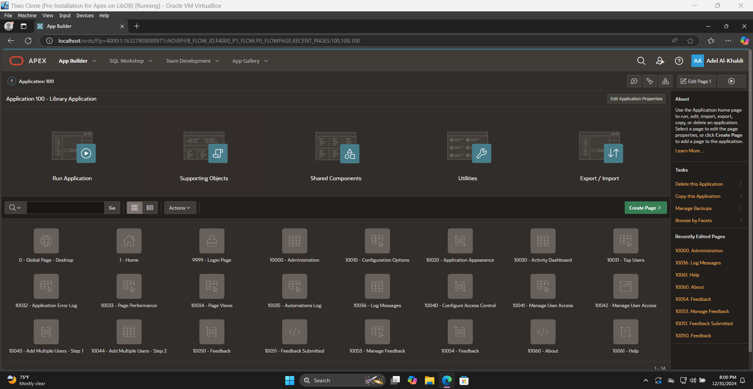

Figure 46, Showing the UI for APEX’s App Builder.

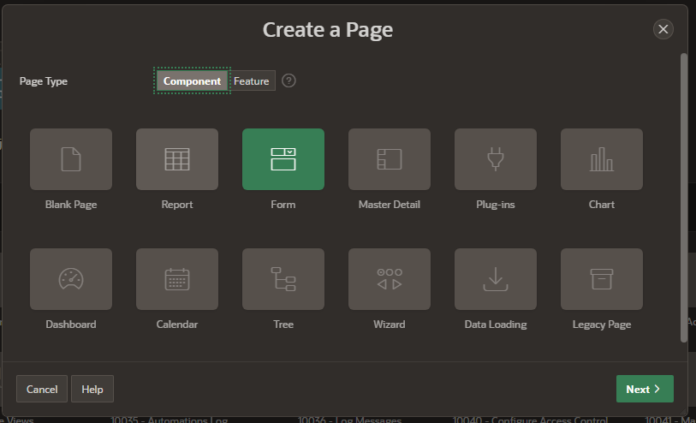

Figure 47, showing the wizard for creating a new page in an APEX application\

.

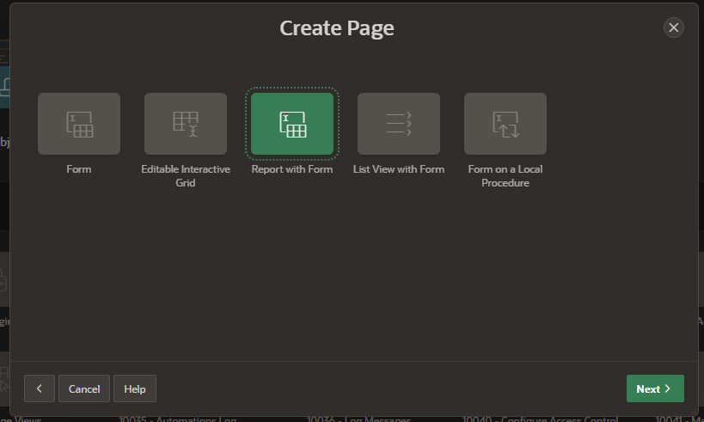

Figure 48, showing the next step in the page creation wizard.

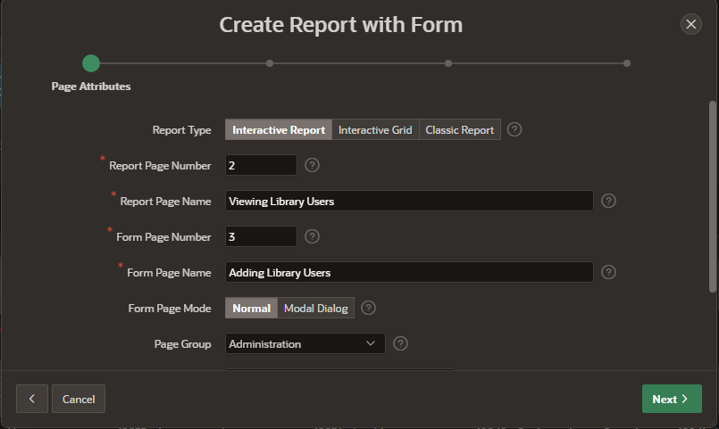

Figure 49, continuation of the wizard.

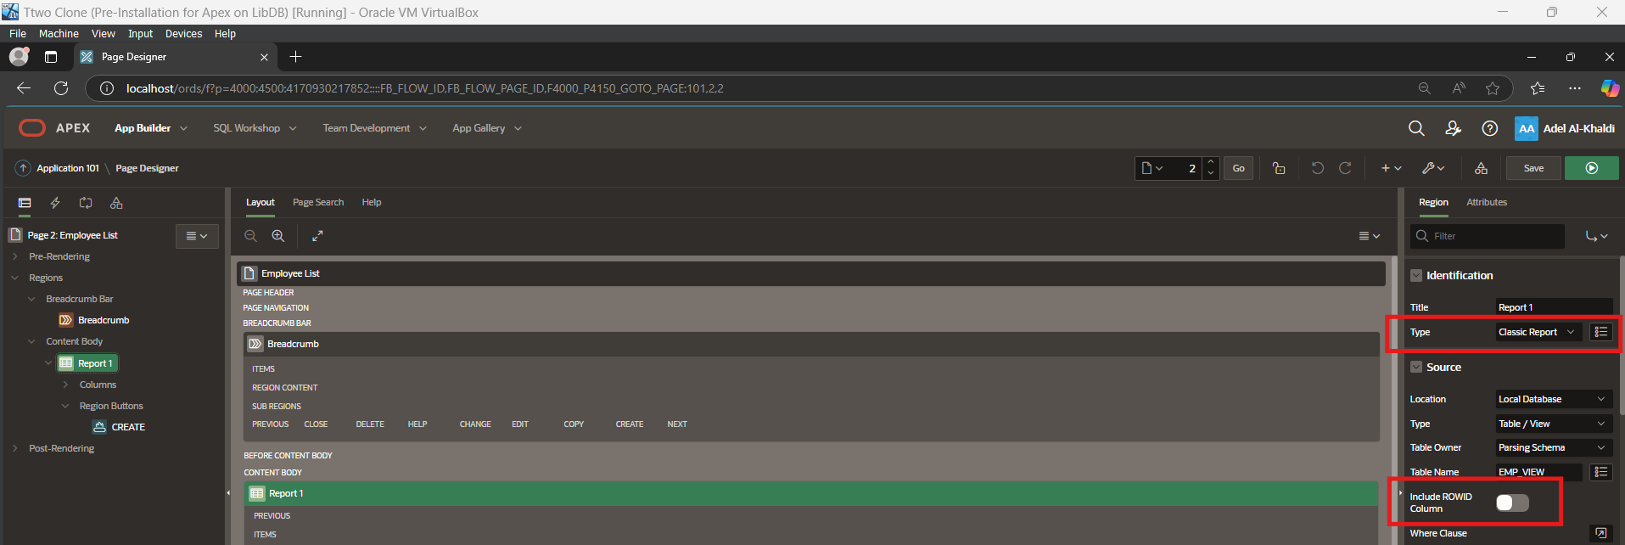

Figure 50, showing the modifications needed to make the report not editable and disabling of the default ROWID column.

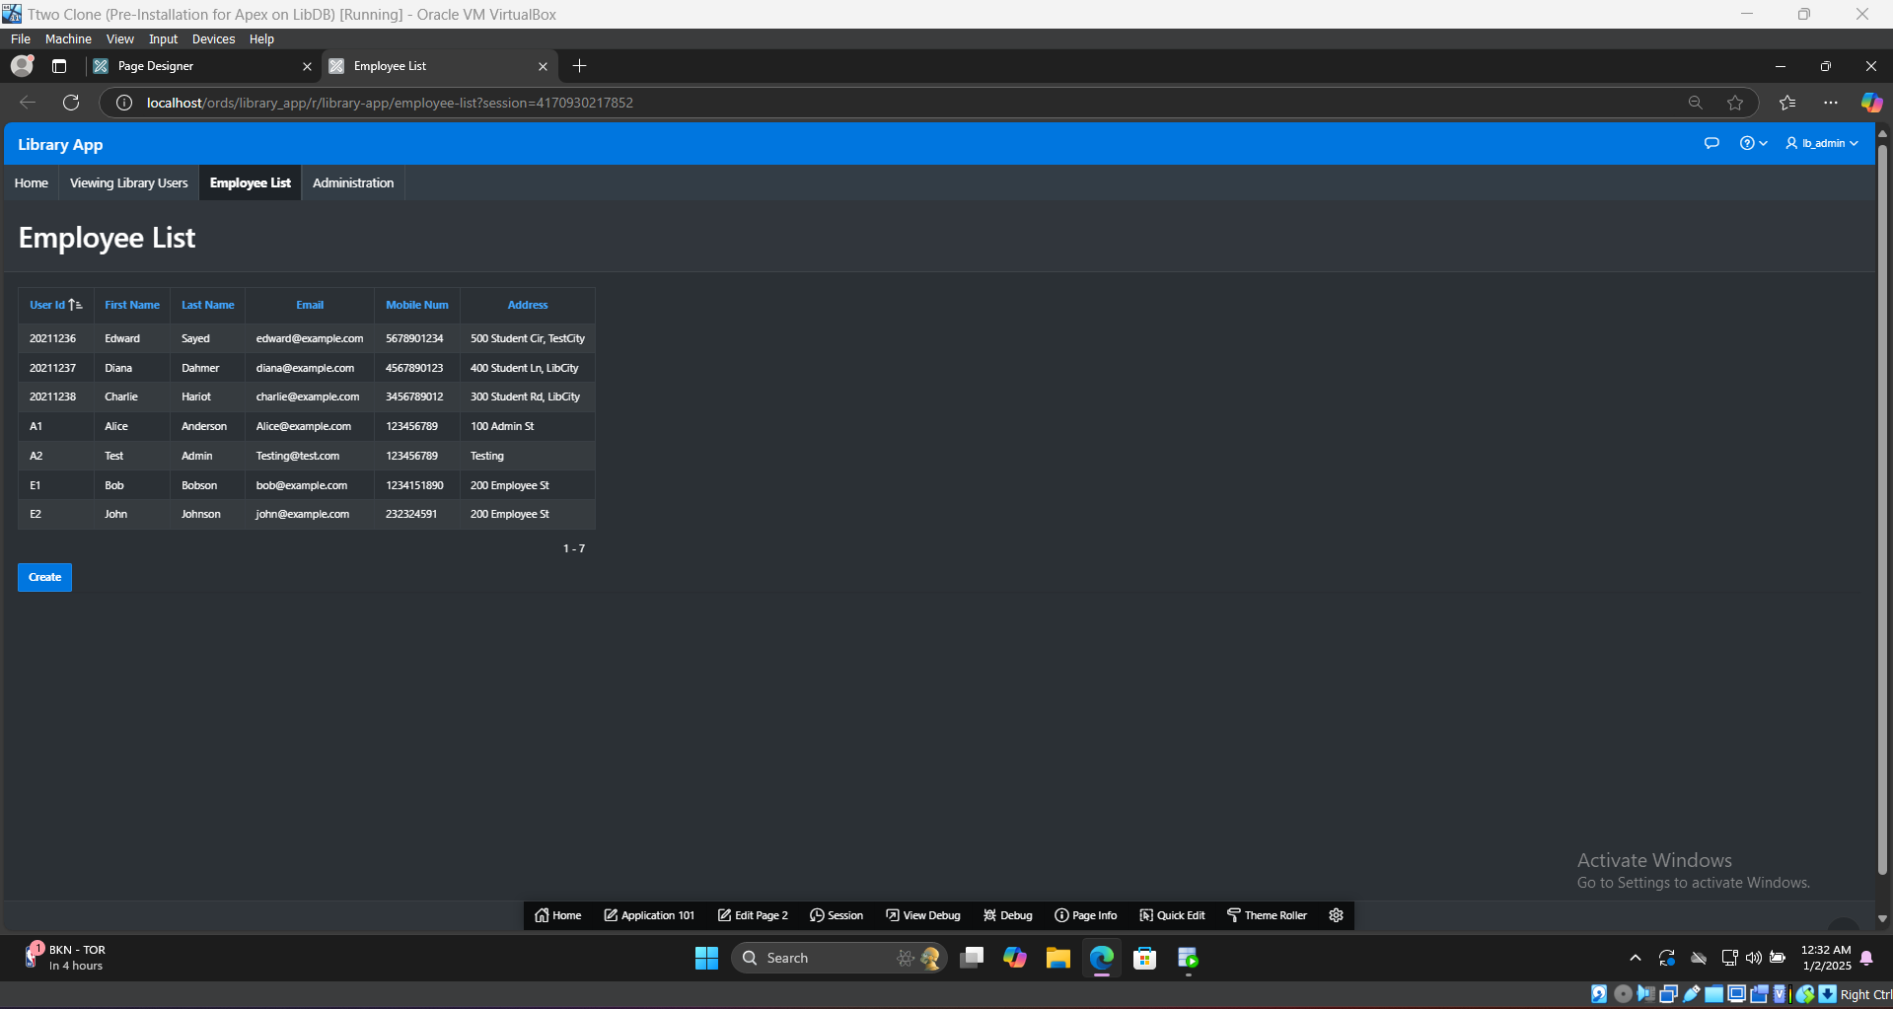

Figure 51, showing the finished reports.

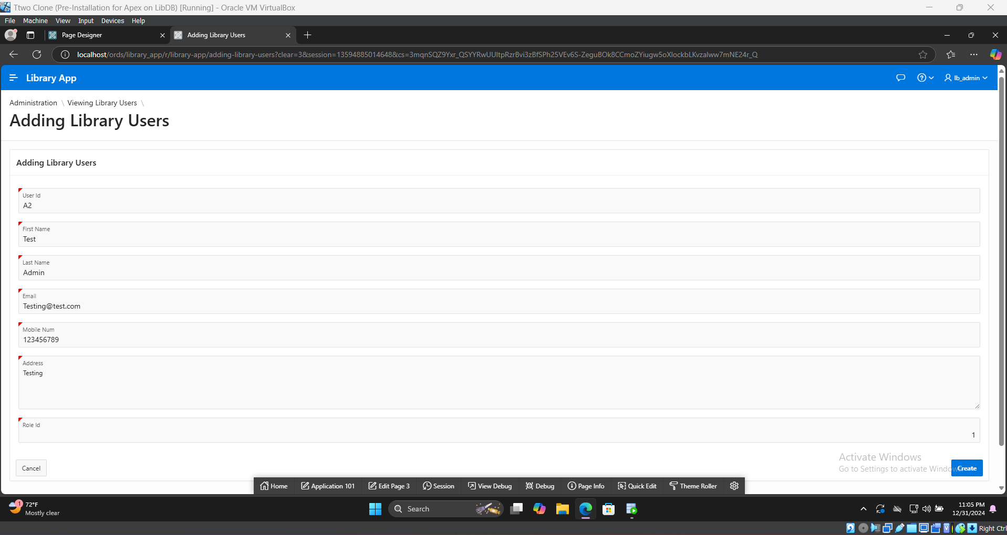

Figure 52, showing the form with test user input.

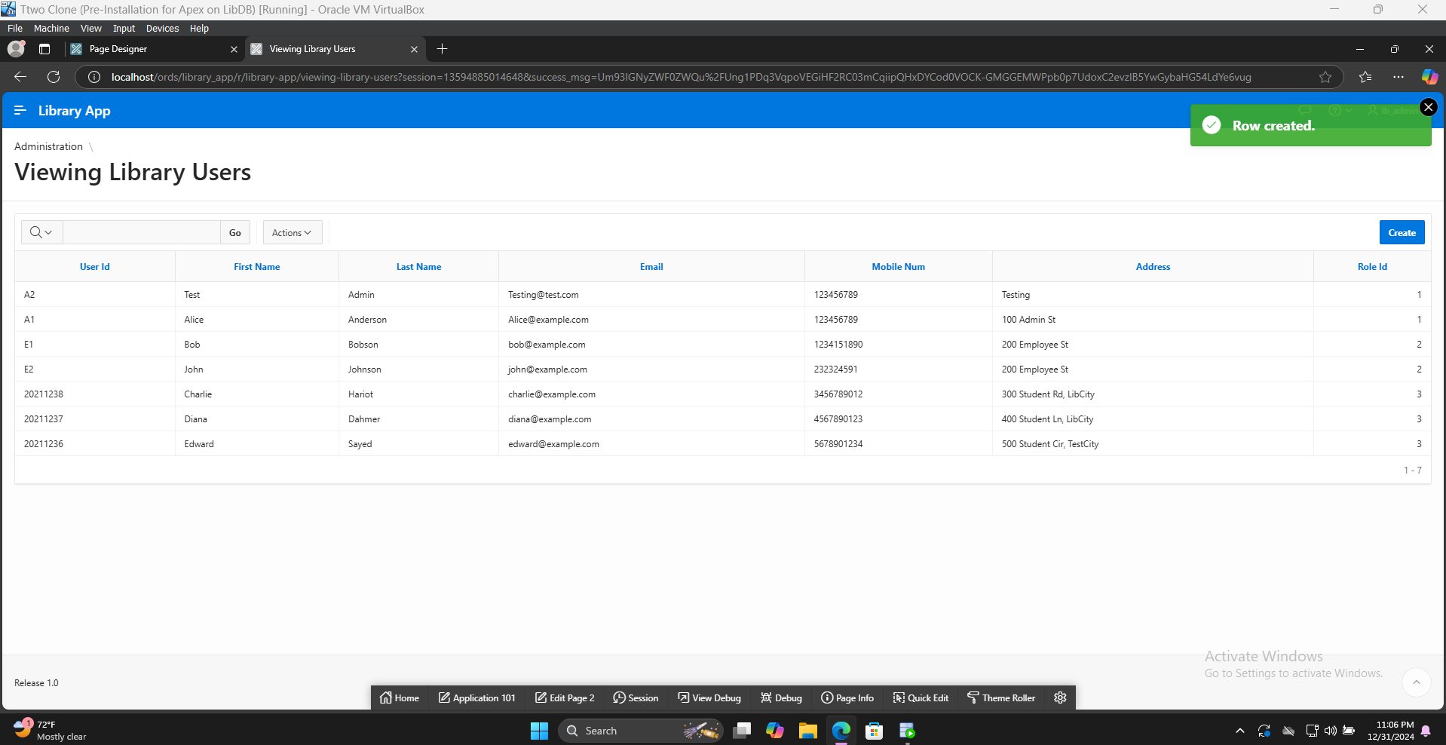

Figure 53, showing the test user shown in APEX report as a library user.

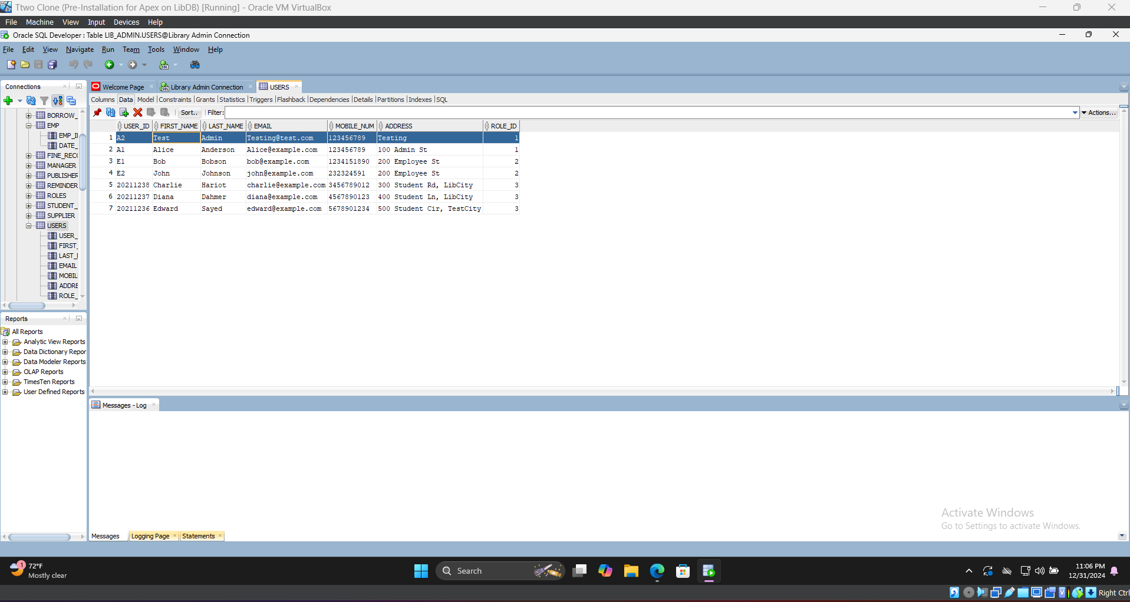

Figure 54, showing the test user from APEX inserted into the database separately from APEX.

### Creating a View for Data in APEX’s SQL Workshop

Views are a way of showing data from multiple tables into and creating an output and then treating it as if it’s a separate table. They are a useful shortcut to reusing the same SQL statements to display data.

They are accessed from SQL workshop, then clicking on the create side menu to make a new view as shown in figure 55 and then in figure 56 showing the SQL code to create the view. We will utilize this view for a classic report similar to the previous section as seen in figure 57, but this time to see the employees and their data by combining users table and employee table in a single view and then a form that adds employees but only if they are already pre-existing in users table and they have role ID = 2, so that they only can add existing employees in the user table.

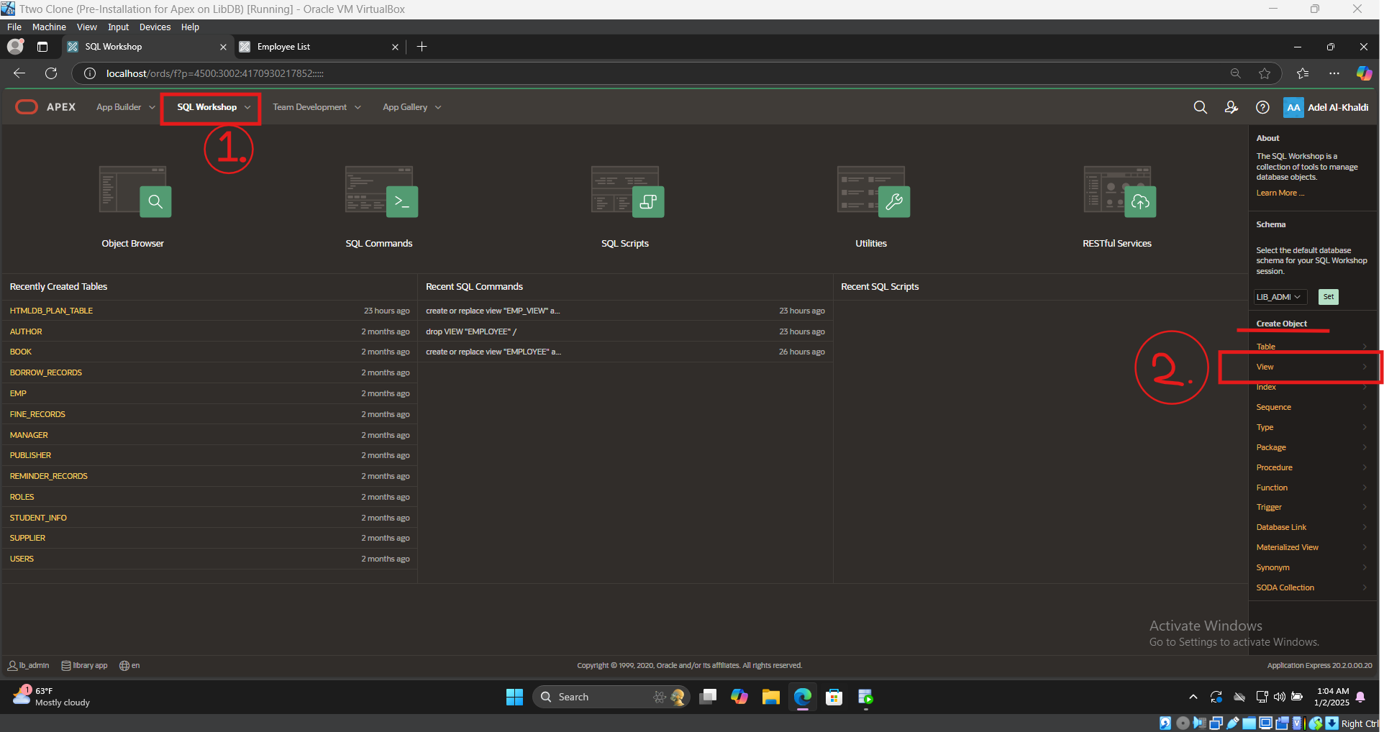

Figure 55, showing the steps to create a view in APEX.

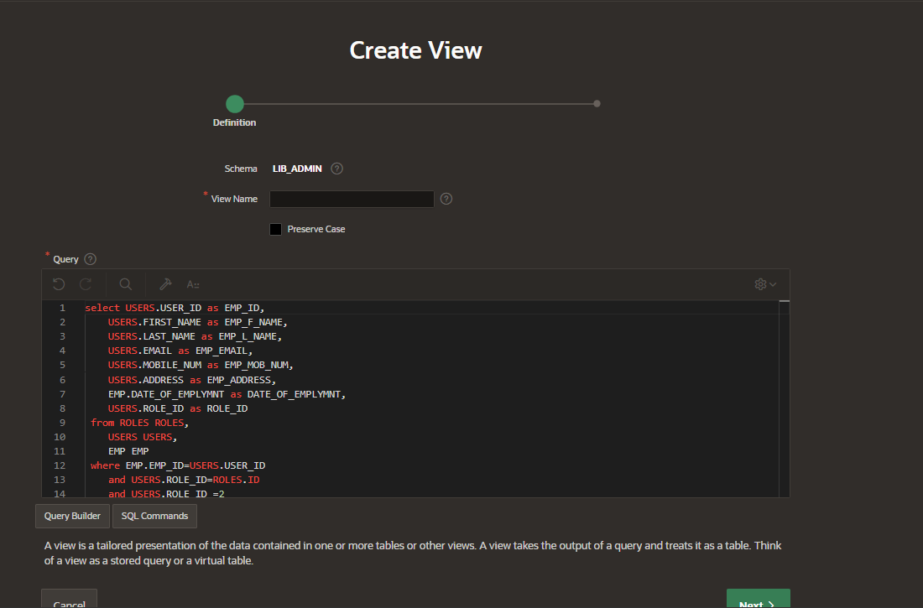

Figure 56, showing SQL code to create the view.

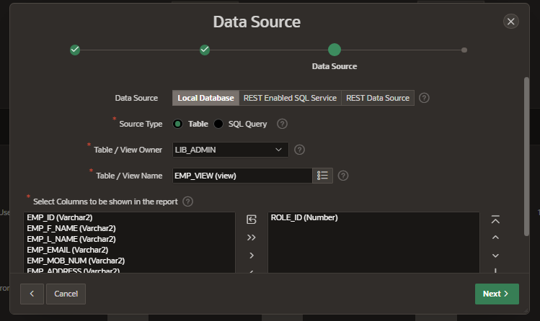

Figure 57, Using the newly created view and including all columns except for role.

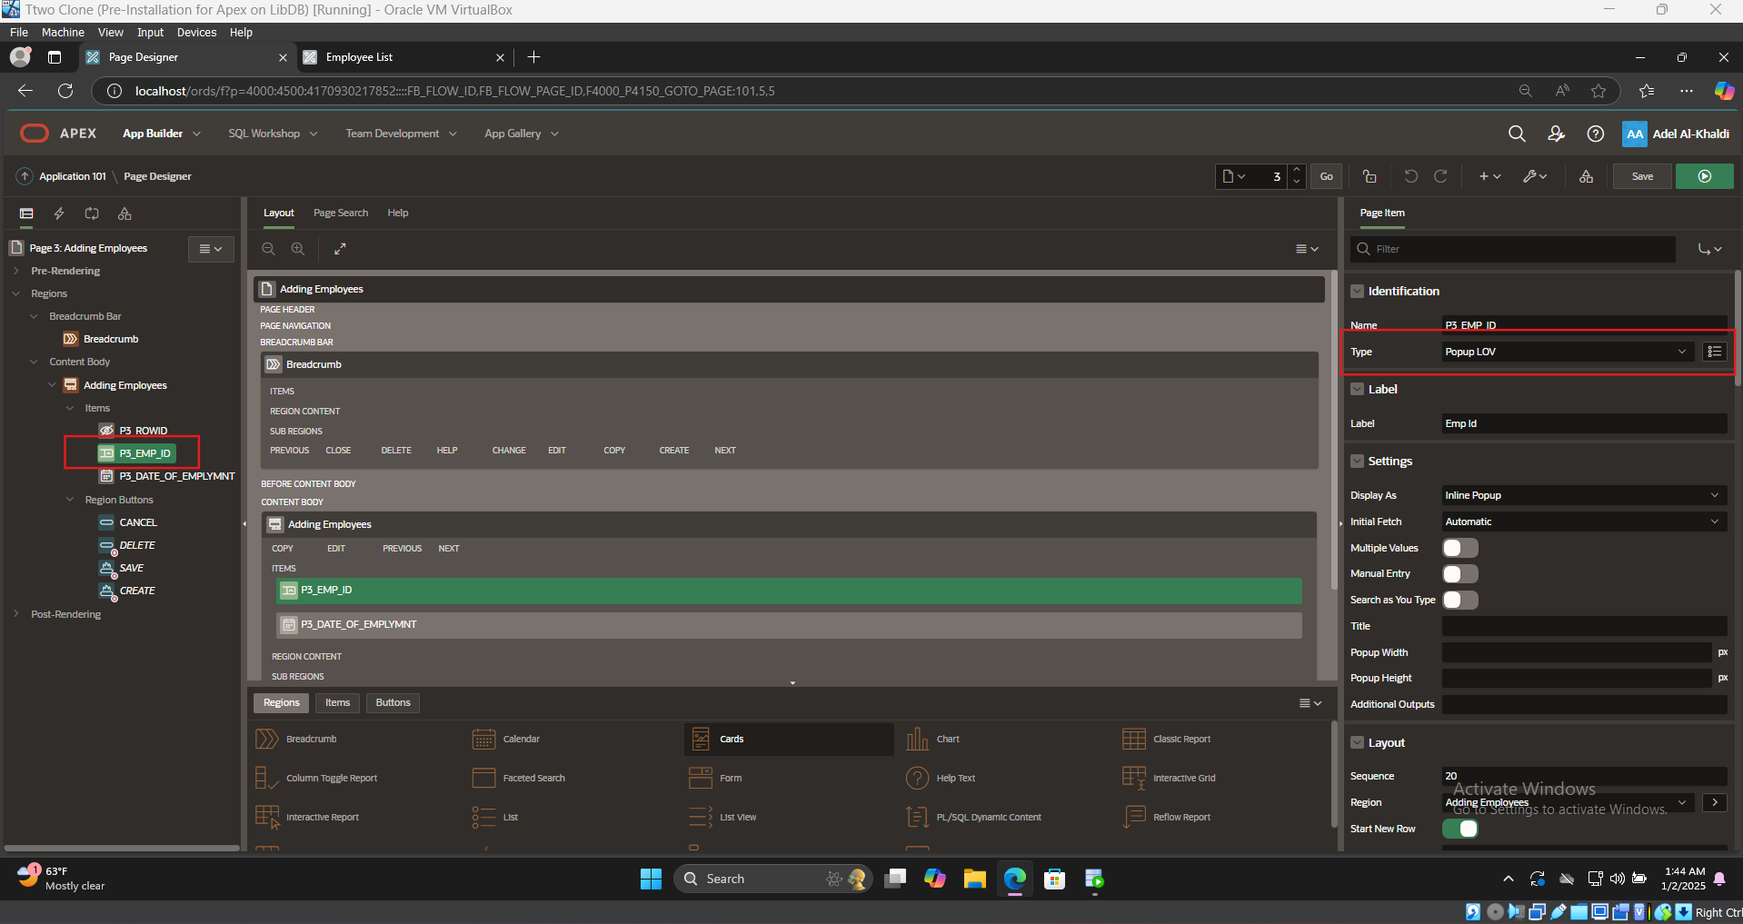

Figure 58, showing how to modify the form field P3_EMP_ID to a Popup LOV selection

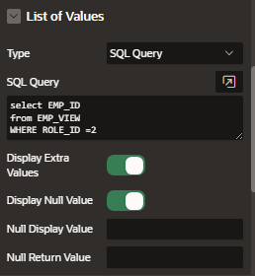

Figure 59, Setting the value for the Popup LOV to show the ID’s of employees only.

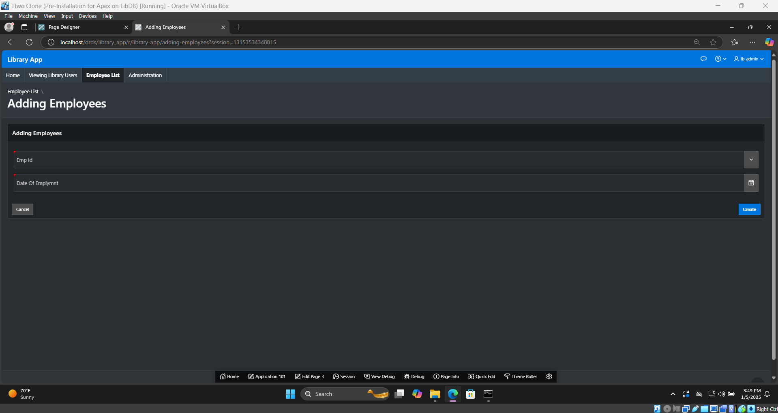

Figure 60, Showing the final result of the page.

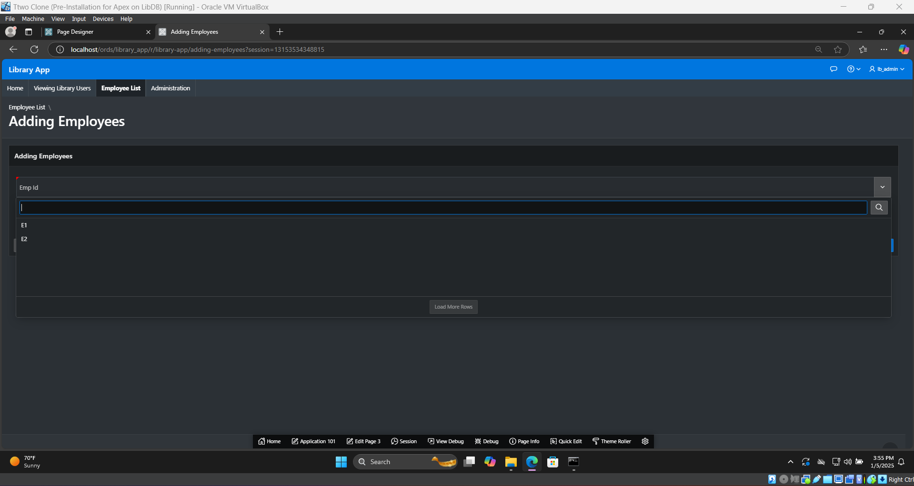

Figure 61, Showing the Pop-up LOV Function implemented with only registered employees accounts that can be activated.

## **IT Support for Student Registration**

The last part of my journey was working as IT support for students and anyone who needed assistance in the last month of my internship.

We were debriefed on the banner, moodle, teams and emails (both outlook and gmail) systems and the possible errors that they may encounter. After debriefing we were immediately set to have posts around the registration office and at the IT center’s front desk in case anyone needed assistance.

Many older students above the age of 30, especially in masters and doctorate programs in the university, were unaware of how their emails worked or that they had a university email to begin with. We helped them by showing them how to access the emails and enable notifications to receive them.

On the other hand newly registered students were unaware of their passwords, and didn’t know how to change them and felt overwhelmed. We helped them through their problems and got them accustomed to the systems. These same students had problems with which course to register and needed academic guidance, as such we showed them how to view this information and other details from the banner system and how to contact them and where their offices are.

Some students had locked accounts due to many reasons from financial issues or being inactive for students and pausing their studies for too long or other reasons, they couldn’t register again. We were tasked with taking them to the IT Center and then double checking that the account is locked before sending them to the general registrar's office to help resolve the issue.

Some students had special requirements, such as registering a course outside of their study plan or having a low GPA and as such were barred from registration. These circumstances require the intervention of the general registrar and signatures and approval of their respective department heads.

Due to the number of students having the same issues and questions about how to access moodle and banner, I’ve created a guide for students on how to access them and had them as WhatsUp messages that I could forward to students' phone numbers whenever they needed assistance. However, as time went on that became unmanageable as well, so I had to resort to a google document with screenshots and steps with QR code printed that directs them to that google document’s URL.

## 

# **Internship Assessment & How It Prepared Me**

## **Technical Skills & Experience**

Learning how to manage and install and configure middleware software for Oracle databases and Oracle suite and Oracle APEX has given me a distinct advantage and a career path that is viable after my internship and graduation.

Most of the work achieved overlaps with Oracle’s pre-existing learning path for their certificates, meaning that most of the skills learned over the course of the internship can be translated into actual working and productive experience.

The most vital skill learned is working through the documentation and being able to use it to install, configure, create, debug and troubleshoot my work thoroughly while understanding the pitfalls that I faced, and how the software or coding language that I am working in is operating without having to rely on someone else and be self sufficient.

## 

## **Difference Between Theory & Practice**

While I have dealt with many of the topics discussed in the internship over the course of my studies, the contrast between them remains clear. While my studies have given me the basic blocks and concepts and ability to begin working, the internship has given me a challenge in terms of thinking of scalable and efficient software that can deliver results in an optimized way.

As mentioned previously, while working on the database schema, there was a major contrast between how the schemas were taught to us versus how they should be built. Learning to think about scalable design aspects is crucial, especially when dealing with software that is subject to change and changing requirements such as library systems being made for students being opened to the public as mentioned previously. In contrast, when we were tasked with creating a schema, the requirements would always be static, never requiring any scalable design or any forward thinking for expansions and how they would occur.

Another important thing that was learned is using industry-standard software. Using Oracle systems and getting acquainted with them and learning their operation is crucial considering it is a standard in most organizations. Using Visual Studio Code is also crucial for web development & other programming endeavors with its plugins and extensions and XAMPP for testing web applications locally is a must. In addition, learning how to deal with GitHub is also vital as it is considered an industry practice for managing any collaborative projects or even individual ones due to its rollback feature that can prevent problems in case of any unpredicted failures or issues in a new version of the software’s deployment.

## **Soft Skills & Teamwork Skills**

While the technical skills gained throughout the internship were useful, the most important lessons that will stick no matter what field of work I would like to pursue are the soft skills gained over the internship.

Most importantly is communication and professional conduct. Learning how to communicate and schedule through emails and teams and face-to-face meetings, delivering reports and debriefs for the supervisor, formulating questions, and extracting requirements from the projects and restrictions was a vital and important skill.

Having emotional intelligence and dealing with colleagues professionally is a must for any workplace to avoid conflict and minimize it. Escalating problems that were faced with colleagues or supervisors by addressing them respectfully and professionally to them first resolved most issues before having to resort to a higher supervisor and further escalating conflict. Another aspect to consider is dealing with frustrated and angry clients. As I have worked in IT support and helped students and their parents deal with these systems, I had to engage respectfully and calmly to avoid escalation and further conflict.

Learning how to delegate tasks and engage in meaningful cooperation and teamwork was important for working with my colleagues and fellow interns. I have helped my colleagues on their own projects as they did for me by sharing my opinions and knowledge about the topics.

Time and project management were necessary to get the deliverables on time. Using shared calendars on Google Calendar and Trello boards to keep track of tasks and their deadline is a vital part of keeping on track with projects.

# **Conclusion**

At the end of my internship, I learned and developed many skills over four months. From professional etiquette and dealing with colleagues and coworkers, to coordinating with them over tools such as Google Calendar and Trello, and finally, hard skills such as web development, Oracle database systems, and APEX. These skills that I have developed will prove vital for my future professional career.

# **References**

[1] P. Huey, D. Keesling, R. Kumar, B. Rich, and R. Strohm, “Introduction to the Multitenant Architecture,” *Oracle Help Center*, 2018. <https://docs.oracle.com/en/database/oracle/oracle-database/19/multi/introduction-to-the-multitenant-architecture.html#GUID-1531D374-BF2B-4F6F-A1E5-11B167B7C604> (accessed Jan. 03, 2025).

[2] P. Huey, R. Kumar, B. Rich, and R. Strohm, “About Application Containers,” *Oracle Help Center*, 2020. <https://docs.oracle.com/en/database/oracle/oracle-database/21/multi/application-containers2.html> (accessed Jan. 03, 2025).

[3] P. Huey, D. Keesling, R. Kumar, B. Rich, and R. Strohm, “Overview of the Multitenant Architecture,” *Oracle Help Center*, 2018. <https://docs.oracle.com/en/database/oracle/oracle-database/19/multi/overview-of-the-multitenant-architecture.html#GUID-49C0C90D-5A72-4131-8C3D-B07341C75CB2> (accessed Jan. 03, 2025).

[4] P. Huey, D. Keesling, R. Kumar, B. Rich, and R. Strohm, “Introduction to the Multitenant Architecture,” *Oracle Help Center*, 2019. <https://docs.oracle.com/en/database/oracle/oracle-database/18/multi/introduction-to-the-multitenant-architecture.html#GUID-31CE5970-4A53-44E0-AEA0-D2F7AE09D7E7> (accessed Jan. 03, 2025).

[5] Prakash Jashnani and J.-F. Verrier, “Operating System Checklist for Oracle Database Installation on Microsoft Windows,” *Oracle Help Center*, 2021. <https://docs.oracle.com/en/database/oracle/oracle-database/19/ntdbi/operating-system-checklist-oracle-database-installation-microsoft-windows.html>

[6] “HMR3Init: Attempting fall back to NEM (Hyper-V is active) - virtualbox.org,” *Virtualbox.org*, Aug. 11, 2020. <https://forums.virtualbox.org/viewtopic.php?f=25&t=99390> (accessed Jan. 03, 2025).

‌[7] D. Williams, Prakash Jashnani, and B. Kumar, “Local Naming Parameters in the tnsnames.ora File,” *Oracle Help Center*, 2020. <https://docs.oracle.com/en/database/oracle/oracle-database/21/netrf/local-naming-parameters-in-tns-ora-file.html> (accessed Jan. 03, 2025).

[8] “Managing Tablespaces,” *Oracle Help Center*, 2019. <https://docs.oracle.com/en/database/oracle/oracle-database/19/admin/managing-tablespaces.html> (accessed Jan. 03, 2025).

[9] “Downloading and Installing APEX,” *Oracle Help Center*, 2023. <https://docs.oracle.com/en/database/oracle/apex/23.1/htmig/downloading-installing-apex.html> (accessed Jan. 03, 2025).

[10] Akshay Badkar, “What is Tomcat? Everything You Need to Know,” *Simplilearn.com*, Jul. 31, 2023. <https://www.simplilearn.com/what-is-tomcat-article#tomcat_vs_other_web_servers> (accessed Jan. 03, 2025).

‌